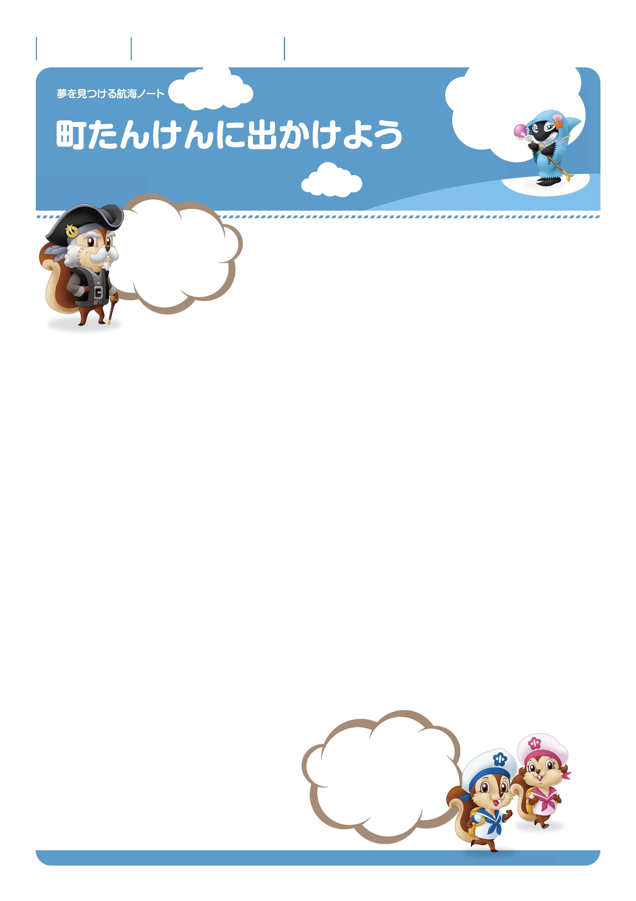

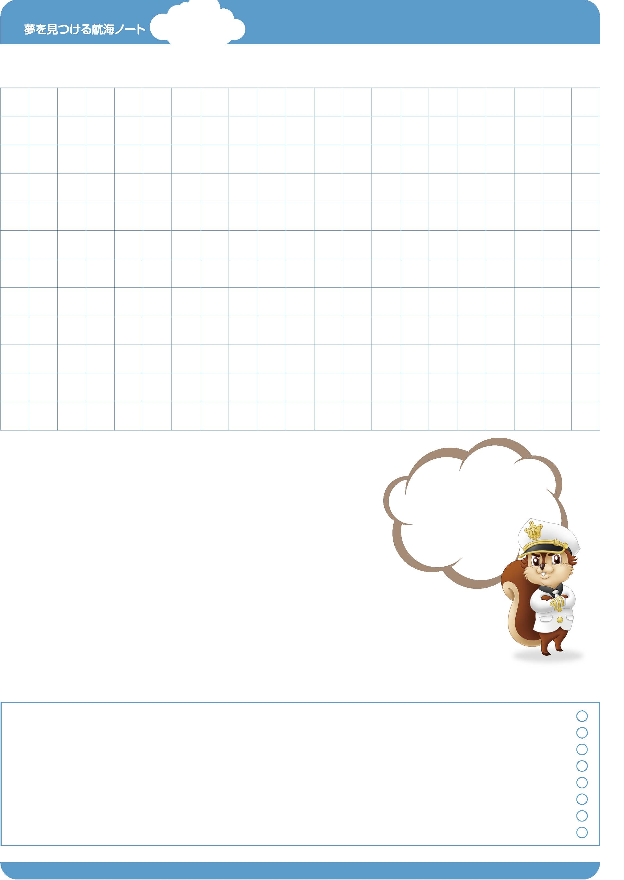
ききたいこと、
みたいこと、
しりたいことなどを
かいてみよう。
町たんけんでがんばりたいことをかきましょう。
---------------------------------------------------------------------------------------------------------------------------------------------------------------------------------------------------------------------------------------------
–-
---------------------------------------------------------------------------------------------------------------------------------------------------------------------------------------------------------------------------------------------
–-
---------------------------------------------------------------------------------------------------------------------------------------------------------------------------------------------------------------------------------------------
–-
---------------------------------------------------------------------------------------------------------------------------------------------------------------------------------------------------------------------------------------------
–-
おりものこうじょう
---------------------------------------------------------------------------------------------------------------------------------------------------------------------------------------------------------------------------------------------
–-
---------------------------------------------------------------------------------------------------------------------------------------------------------------------------------------------------------------------------------------------
–-
---------------------------------------------------------------------------------------------------------------------------------------------------------------------------------------------------------------------------------------------
–-
町たんけんできいたこと、見つけたことをたくさんかきましょう。
---------------------------------------------------------------------------------------------------------------------------------------------------------------------------------------------------------------------------------------------
–-
クリーニング店
---------------------------------------------------------------------------------------------------------------------------------------------------------------------------------------------------------------------------------------------
–-
---------------------------------------------------------------------------------------------------------------------------------------------------------------------------------------------------------------------------------------------
–-
---------------------------------------------------------------------------------------------------------------------------------------------------------------------------------------------------------------------------------------------
–-
---------------------------------------------------------------------------------------------------------------------------------------------------------------------------------------------------------------------------------------------
–-
さかなや
---------------------------------------------------------------------------------------------------------------------------------------------------------------------------------------------------------------------------------------------
–-
---------------------------------------------------------------------------------------------------------------------------------------------------------------------------------------------------------------------------------------------
–-
---------------------------------------------------------------------------------------------------------------------------------------------------------------------------------------------------------------------------------------------
–-
---------------------------------------------------------------------------------------------------------------------------------------------------------------------------------------------------------------------------------------------
–-
ゆうびんきょく
---------------------------------------------------------------------------------------------------------------------------------------------------------------------------------------------------------------------------------------------
–-
---------------------------------------------------------------------------------------------------------------------------------------------------------------------------------------------------------------------------------------------
–-
---------------------------------------------------------------------------------------------------------------------------------------------------------------------------------------------------------------------------------------------
–-
---------------------------------------------------------------------------------------------------------------------------------------------------------------------------------------------------------------------------------------------
–-
びっくりした！
かんどうした！ はじめてだった！
きみの“しんはっけん”を
かいてみよう。
No.14-01
じぶんのせかいを
ひろげよう。
がつ にち
なまえ

2
ねん くみ ばん

No.14-02
町たんけんの一ばんの思い出を絵にしましょう。
先生から
-----------------------------------------------------------------------------------------------------------------------
-----------------------------------------------------------------------------------------------------------------------
-----------------------------------------------------------------------------------------------------------------------
おうちの人から

-----------------------------------------------------------------------------------------------------------------------
-----------------------------------------------------------------------------------------------------------------------
-----------------------------------------------------------------------------------------------------------------------
町たんけんでがんばったことを書きましょう。
---------------------------------------------------------------------------------------------------------------------------------------------------------------------------------------------------------------------------------------------
–-
---------------------------------------------------------------------------------------------------------------------------------------------------------------------------------------------------------------------------------------------
–-
---------------------------------------------------------------------------------------------------------------------------------------------------------------------------------------------------------------------------------------------
–-
---------------------------------------------------------------------------------------------------------------------------------------------------------------------------------------------------------------------------------------------
–-
---------------------------------------------------------------------------------------------------------------------------------------------------------------------------------------------------------------------------------------------
–-
---------------------------------------------------------------------------------------------------------------------------------------------------------------------------------------------------------------------------------------------
–-
たんけん前に書いた
「がんばりたいこと」は
できたかな。

ゆめ
み
こうかい
ゆめ
み
こうかい

