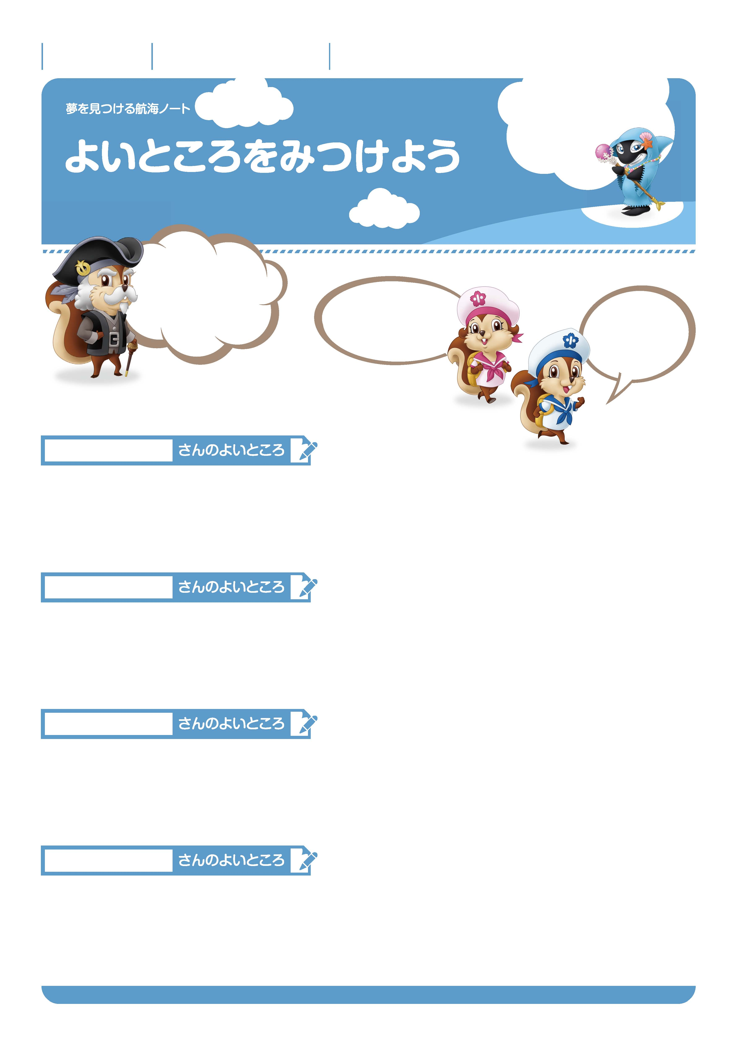

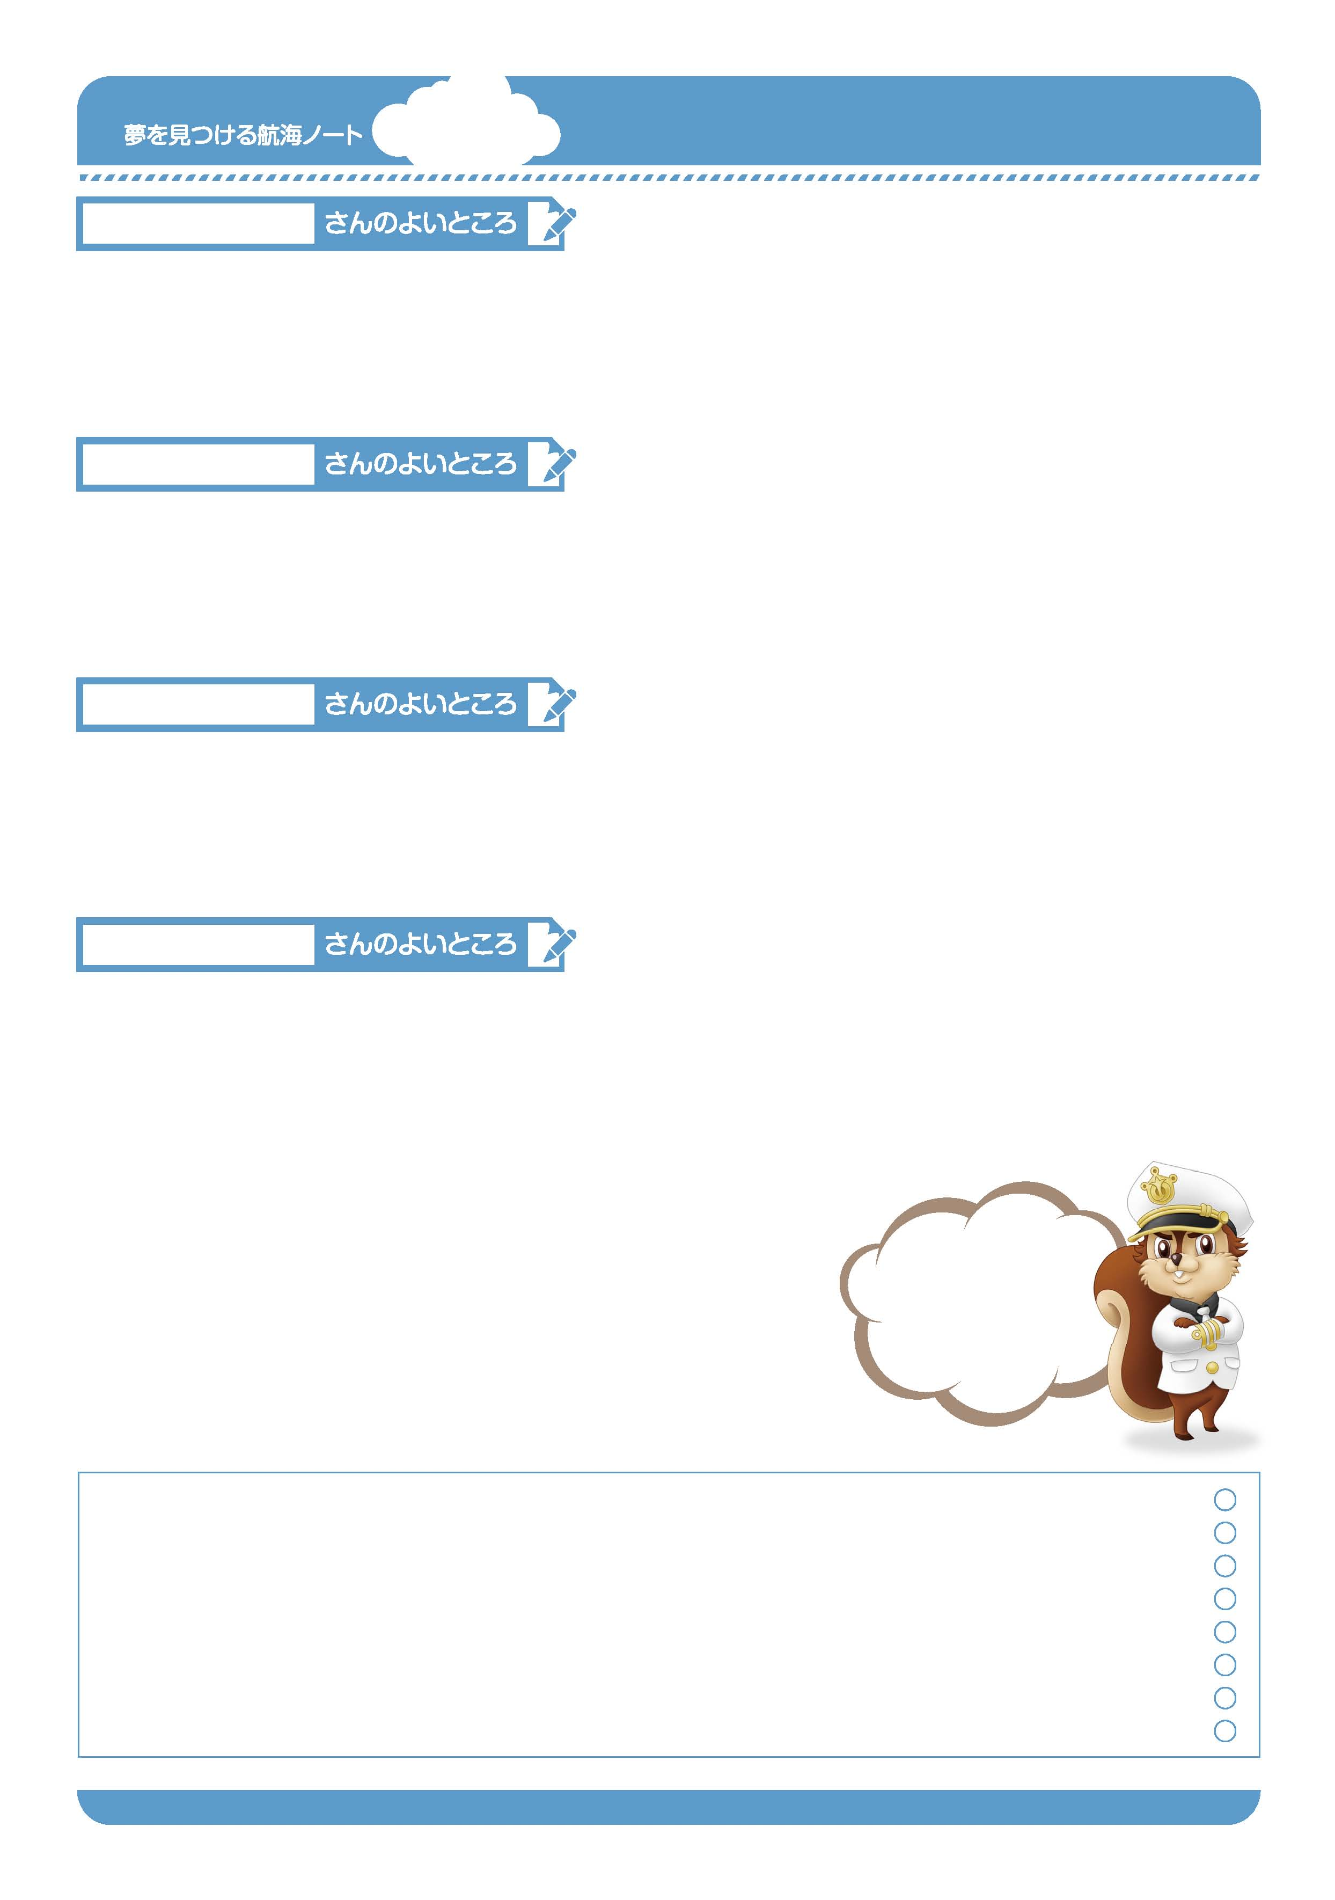
月 日
年 組 番
名前

3
No.16-01
今のじぶんの
よさを知ろう。
友達のよさを
知ろう。
「よいところ」って
なんだろう。
そこから考えてみよう。
ノッキーのよいところは、
やさしいところね。
---------------------------------------------------------------------------------------------------------------------------------------------------------------------------------------------------------------------------------------------
–-

---------------------------------------------------------------------------------------------------------------------------------------------------------------------------------------------------------------------------------------------
–-
ハナの
よいところは、
正直な
ところだよ。
---------------------------------------------------------------------------------------------------------------------------------------------------------------------------------------------------------------------------------------------
–-

---------------------------------------------------------------------------------------------------------------------------------------------------------------------------------------------------------------------------------------------
–-
---------------------------------------------------------------------------------------------------------------------------------------------------------------------------------------------------------------------------------------------
–-

---------------------------------------------------------------------------------------------------------------------------------------------------------------------------------------------------------------------------------------------
–-
友達のよいところをみつけましょう。
---------------------------------------------------------------------------------------------------------------------------------------------------------------------------------------------------------------------------------------------
–-

---------------------------------------------------------------------------------------------------------------------------------------------------------------------------------------------------------------------------------------------
–-

---------------------------------------------------------------------------------------------------------------------------------------------------------------------------------------------------------------------------------------------
–-

---------------------------------------------------------------------------------------------------------------------------------------------------------------------------------------------------------------------------------------------
–-
---------------------------------------------------------------------------------------------------------------------------------------------------------------------------------------------------------------------------------------------
–-

---------------------------------------------------------------------------------------------------------------------------------------------------------------------------------------------------------------------------------------------
–-
---------------------------------------------------------------------------------------------------------------------------------------------------------------------------------------------------------------------------------------------
–-

---------------------------------------------------------------------------------------------------------------------------------------------------------------------------------------------------------------------------------------------
–-
---------------------------------------------------------------------------------------------------------------------------------------------------------------------------------------------------------------------------------------------
–-

---------------------------------------------------------------------------------------------------------------------------------------------------------------------------------------------------------------------------------------------
–-
---------------------------------------------------------------------------------------------------------------------------------------------------------------------------------------------------------------------------------------------
-

---------------------------------------------------------------------------------------------------------------------------------------------------------------------------------------------------------------------------------------------
-
---------------------------------------------------------------------------------------------------------------------------------------------------------------------------------------------------------------------------------------------
-
友達の発表を聞いて、自分のよいところを書きましょう。
きみが気づいていない、
きみ自身のよいところを
いくつはっけん
できたかな。
先生から
-----------------------------------------------------------------------------------------------------------------------
-----------------------------------------------------------------------------------------------------------------------
-----------------------------------------------------------------------------------------------------------------------
おうちの人から

-----------------------------------------------------------------------------------------------------------------------
-----------------------------------------------------------------------------------------------------------------------
-----------------------------------------------------------------------------------------------------------------------
No.16-02

ゆめ
み
こうかい
ゆめ
み
こうかい

