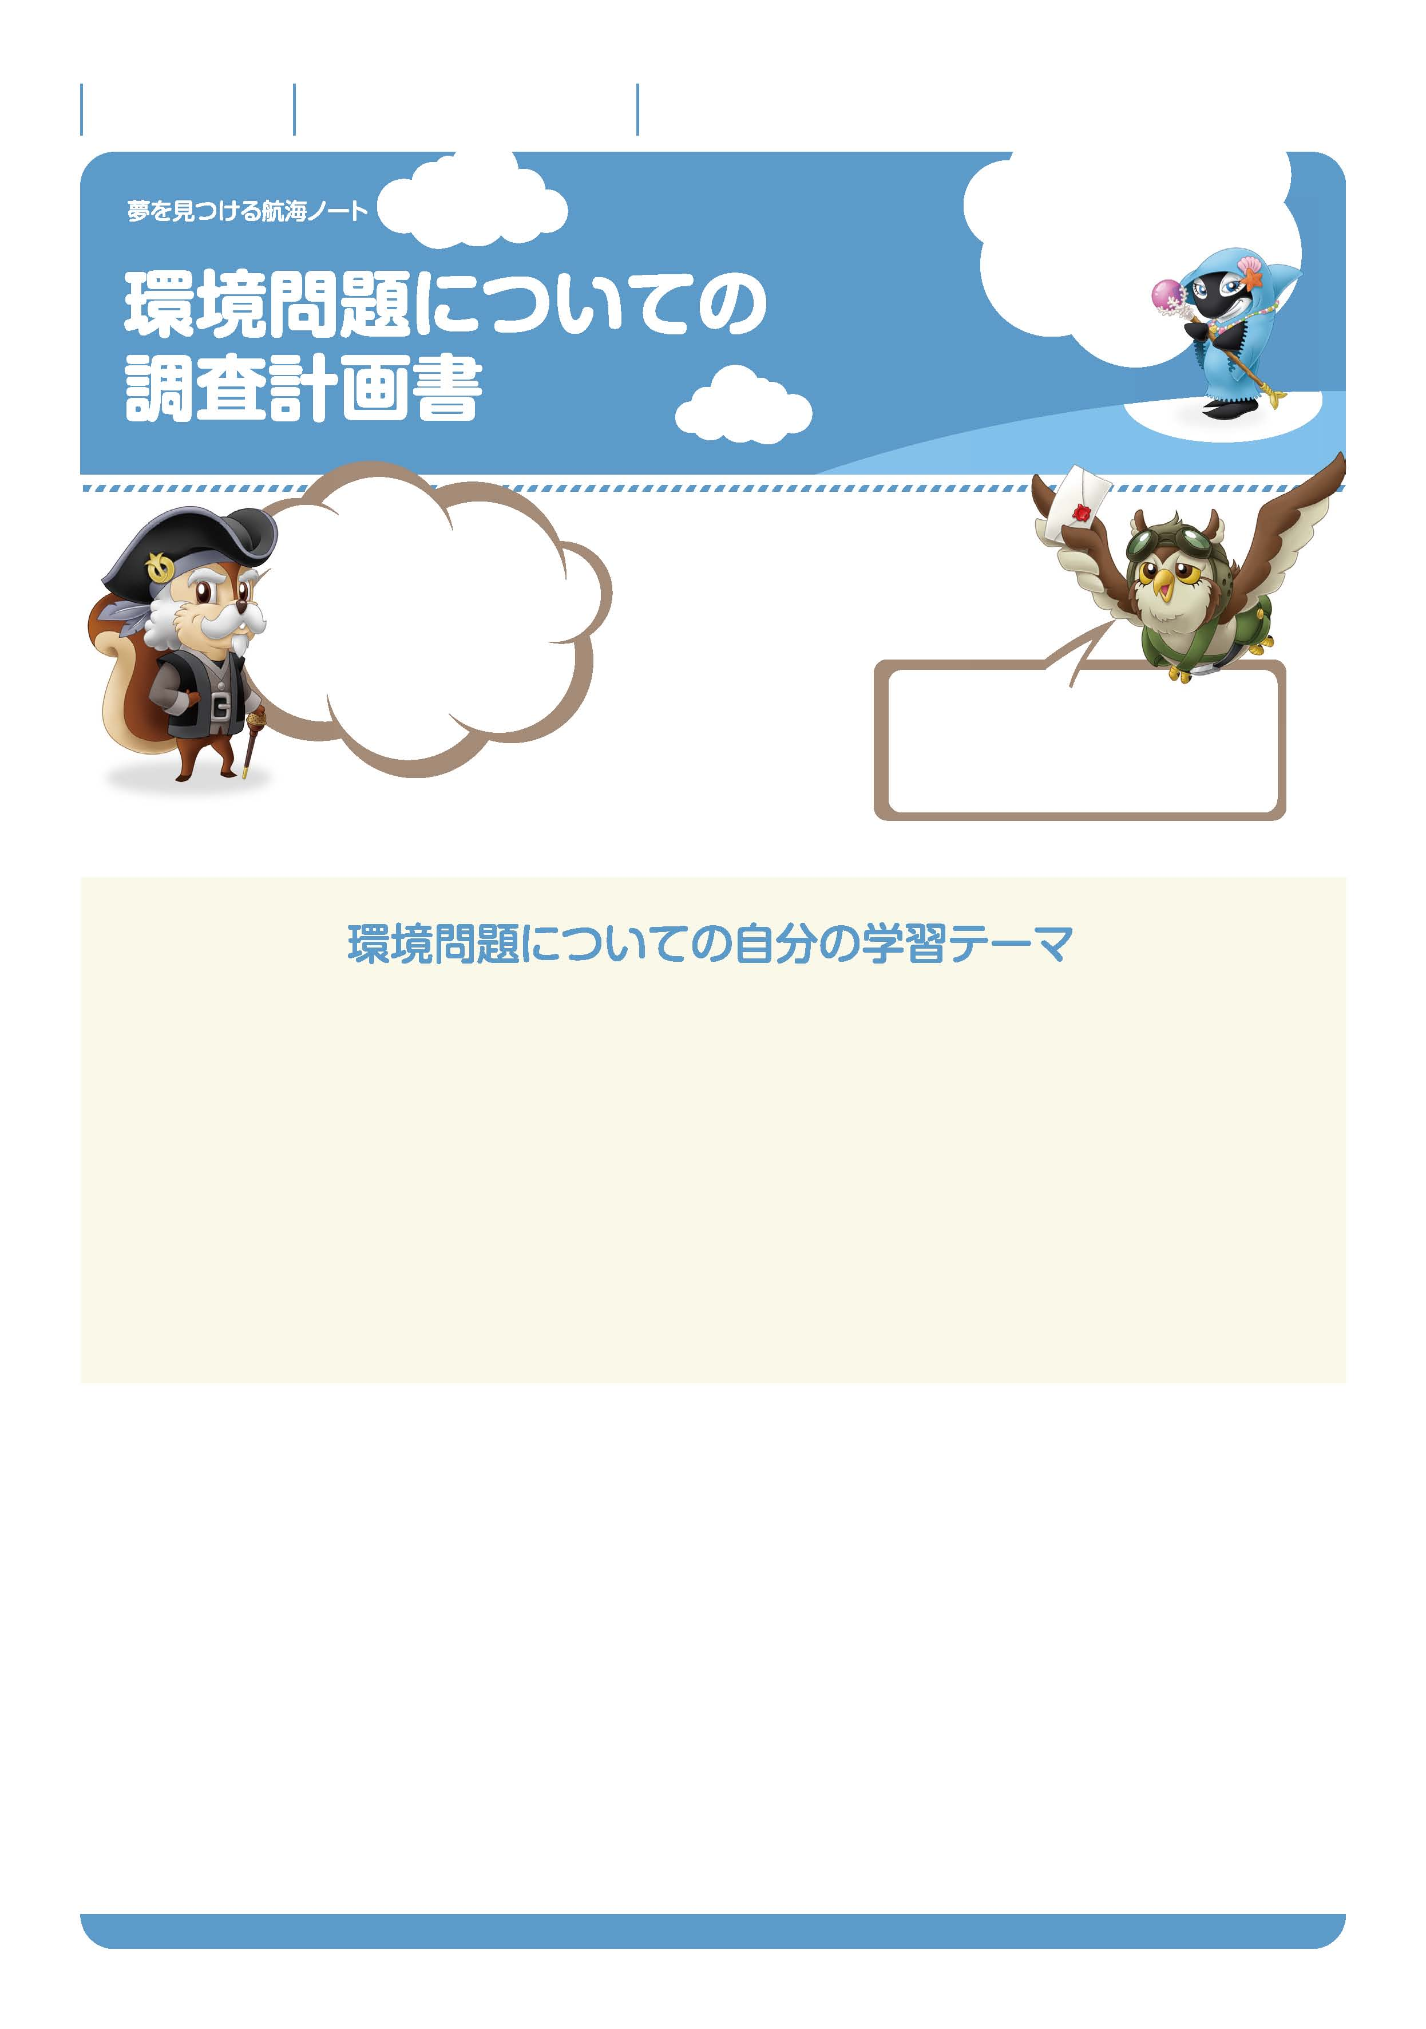

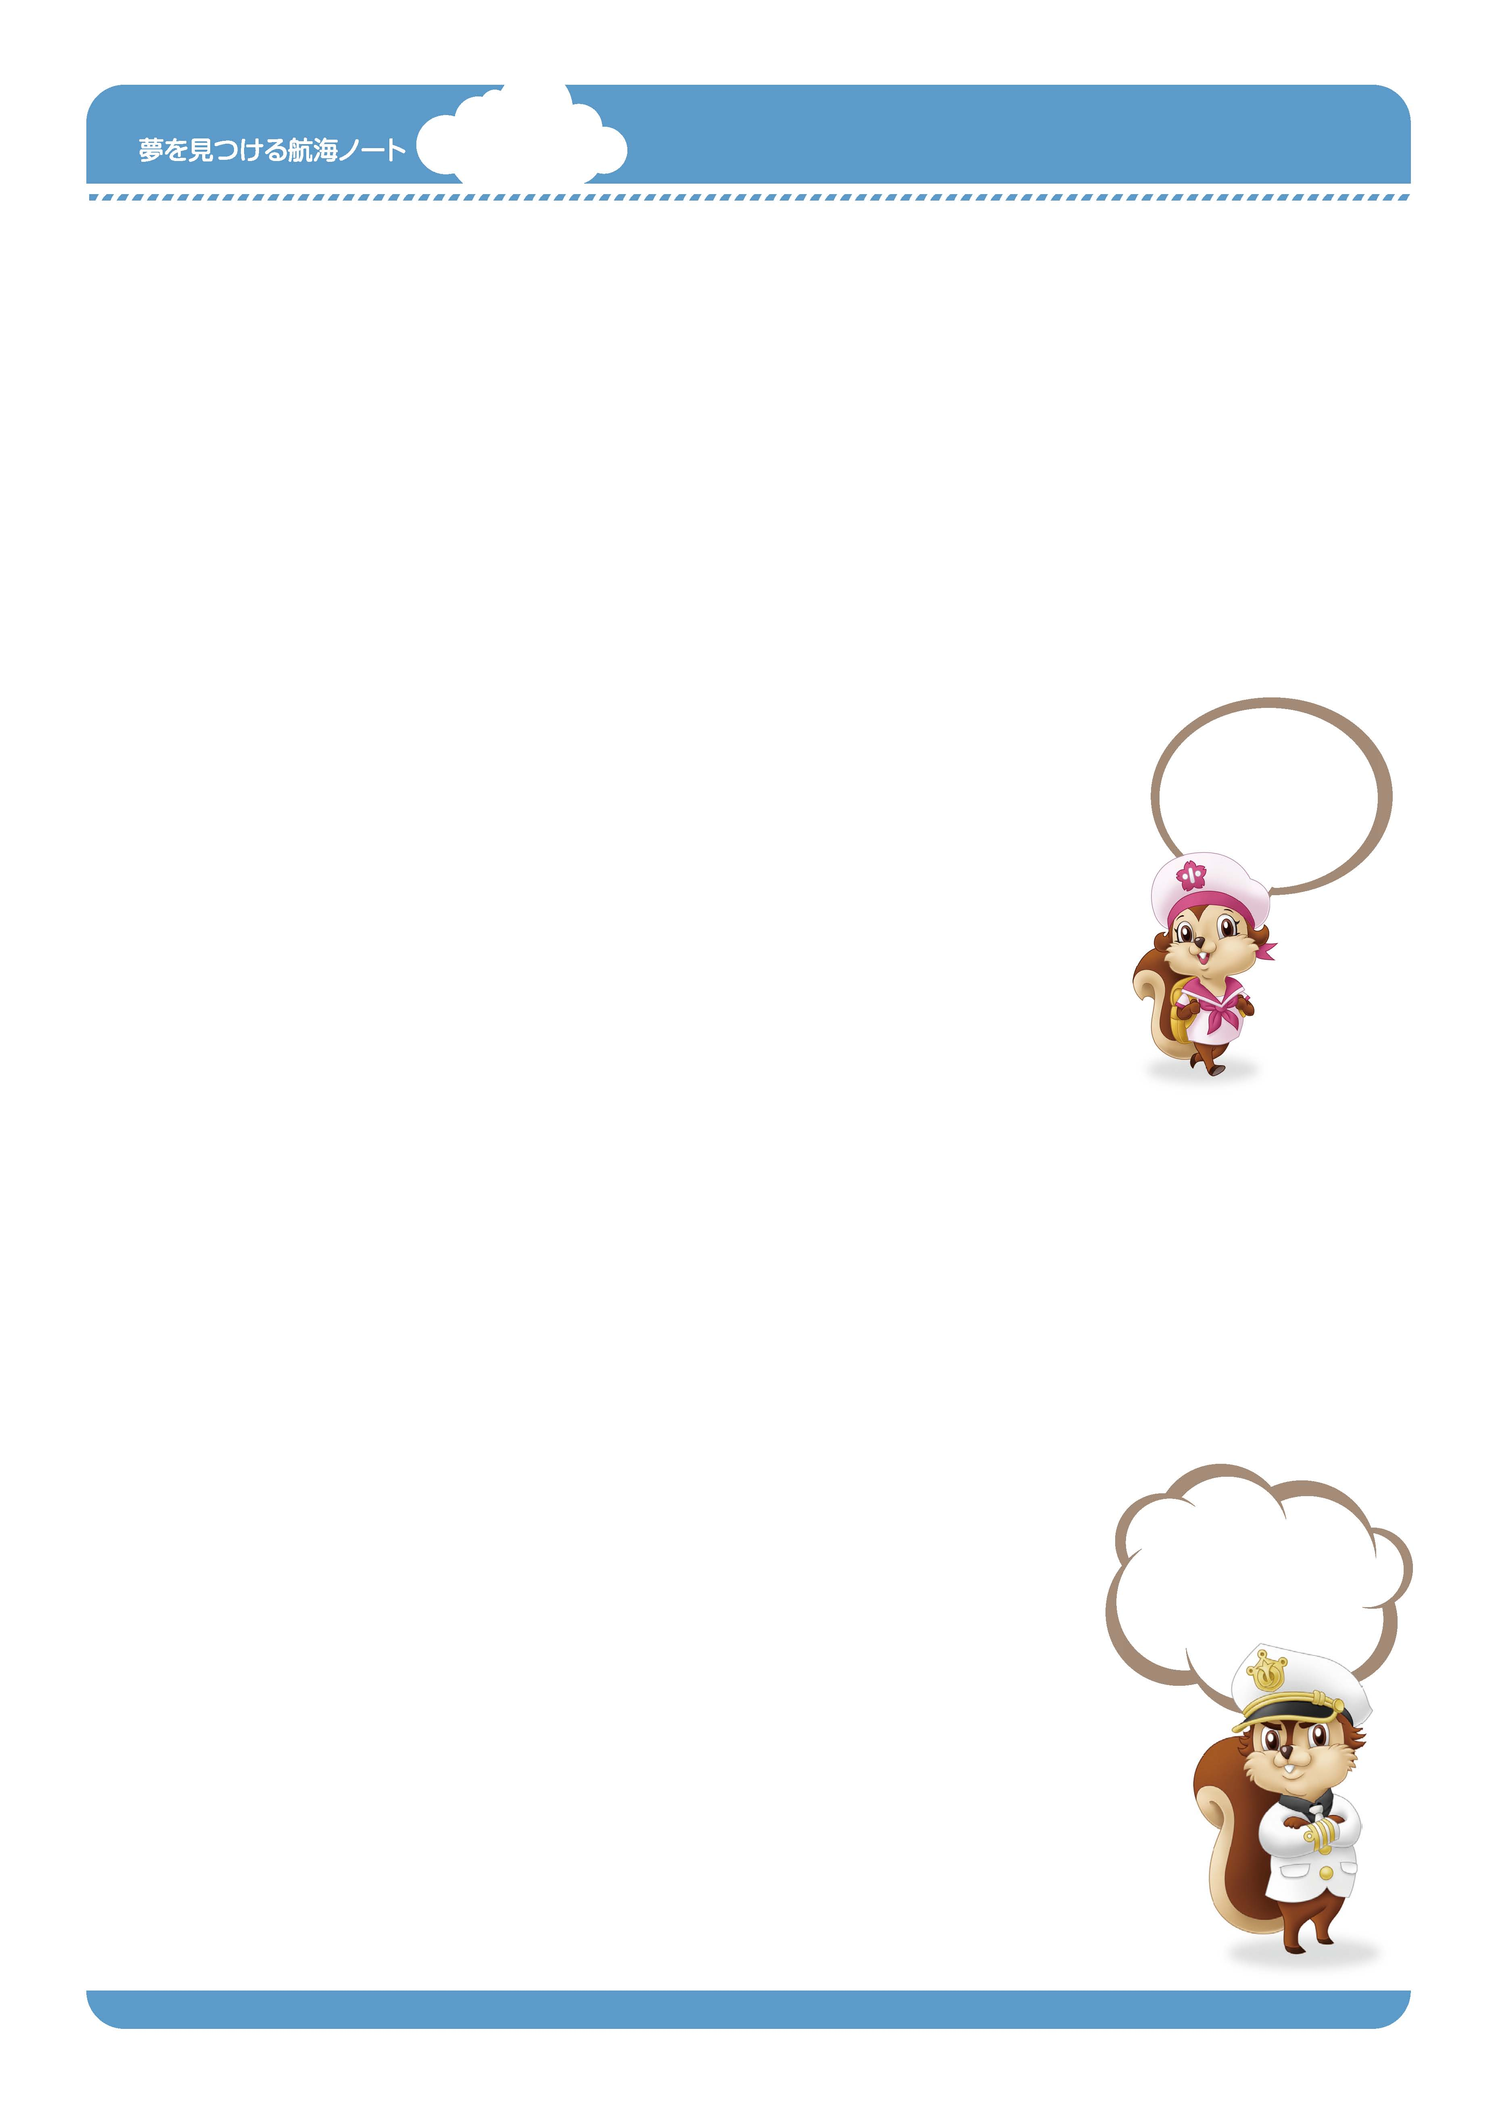
月 日
年 組 番
名前

4
調べて、考えて、
よりよい計画を
立てよう。
No.18-01
コノハが言うように、
身のまわりに
環境問題を考えるきっかけは
いっぱいあるんだ。
今きみが書いているこの紙は、
木からできているんだ。
大切な資源をむだにしないようにね。

かん きょう
---------------------------------------------------------------------------------------------------------------------------------------------------------------------------------------------------------------------------------------------
-

---------------------------------------------------------------------------------------------------------------------------------------------------------------------------------------------------------------------------------------------
-
---------------------------------------------------------------------------------------------------------------------------------------------------------------------------------------------------------------------------------------------
-
---------------------------------------------------------------------------------------------------------------------------------------------------------------------------------------------------------------------------------------------
–-
---------------------------------------------------------------------------------------------------------------------------------------------------------------------------------------------------------------------------------------------
–-
調べる方法をできるだけ多く書き出してみましょう。
---------------------------------------------------------------------------------------------------------------------------------------------------------------------------------------------------------------------------------------------
–-
---------------------------------------------------------------------------------------------------------------------------------------------------------------------------------------------------------------------------------------------
–-
---------------------------------------------------------------------------------------------------------------------------------------------------------------------------------------------------------------------------------------------
–-
---------------------------------------------------------------------------------------------------------------------------------------------------------------------------------------------------------------------------------------------
–-

かん

きょう

ちょう さ
No.18-02
自分の学習テーマについてふさわしい調べ方を選び、計画を立てましょう。
自分の学習テーマにふさわしい調べ方はどんな方法ですか。
実際にお話を
聞きに行きたいな。
何を、どんな方法で、
いつまでに調べるか。
それらを考えてみよう。
ゆめ
み
こうかい
---------------------------------------------------------------------------------------------------------------------------------------------------------------------------------------------------------------------------------------------
-

---------------------------------------------------------------------------------------------------------------------------------------------------------------------------------------------------------------------------------------------
-
---------------------------------------------------------------------------------------------------------------------------------------------------------------------------------------------------------------------------------------------
-
---------------------------------------------------------------------------------------------------------------------------------------------------------------------------------------------------------------------------------------------
-
---------------------------------------------------------------------------------------------------------------------------------------------------------------------------------------------------------------------------------------------
-
---------------------------------------------------------------------------------------------------------------------------------------------------------------------------------------------------------------------------------------------
-
---------------------------------------------------------------------------------------------------------------------------------------------------------------------------------------------------------------------------------------------
-
---------------------------------------------------------------------------------------------------------------------------------------------------------------------------------------------------------------------------------------------
-
---------------------------------------------------------------------------------------------------------------------------------------------------------------------------------------------------------------------------------------------
-
---------------------------------------------------------------------------------------------------------------------------------------------------------------------------------------------------------------------------------------------
-
---------------------------------------------------------------------------------------------------------------------------------------------------------------------------------------------------------------------------------------------
-
---------------------------------------------------------------------------------------------------------------------------------------------------------------------------------------------------------------------------------------------
-
---------------------------------------------------------------------------------------------------------------------------------------------------------------------------------------------------------------------------------------------
-

---------------------------------------------------------------------------------------------------------------------------------------------------------------------------------------------------------------------------------------------
-
---------------------------------------------------------------------------------------------------------------------------------------------------------------------------------------------------------------------------------------------
-
---------------------------------------------------------------------------------------------------------------------------------------------------------------------------------------------------------------------------------------------
-
---------------------------------------------------------------------------------------------------------------------------------------------------------------------------------------------------------------------------------------------
-
---------------------------------------------------------------------------------------------------------------------------------------------------------------------------------------------------------------------------------------------
-
---------------------------------------------------------------------------------------------------------------------------------------------------------------------------------------------------------------------------------------------
-
---------------------------------------------------------------------------------------------------------------------------------------------------------------------------------------------------------------------------------------------
-
---------------------------------------------------------------------------------------------------------------------------------------------------------------------------------------------------------------------------------------------
-
---------------------------------------------------------------------------------------------------------------------------------------------------------------------------------------------------------------------------------------------
-
---------------------------------------------------------------------------------------------------------------------------------------------------------------------------------------------------------------------------------------------
-
---------------------------------------------------------------------------------------------------------------------------------------------------------------------------------------------------------------------------------------------
-
ゆめ
み
こうかい

