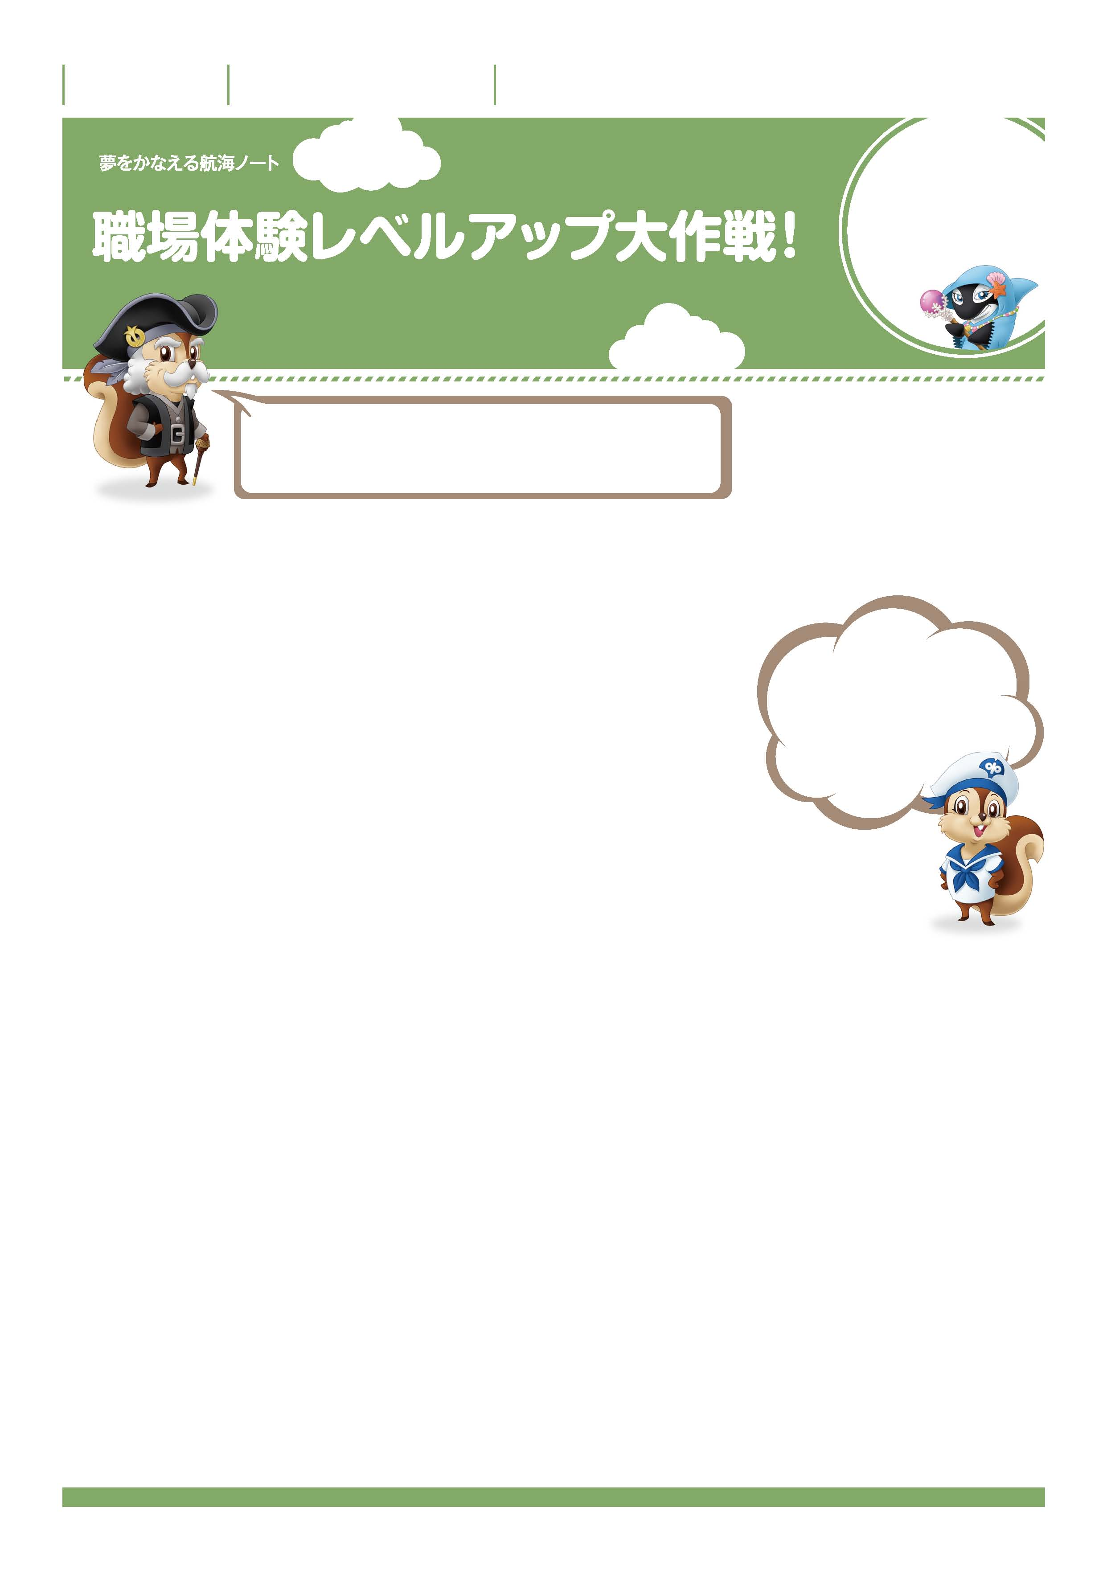

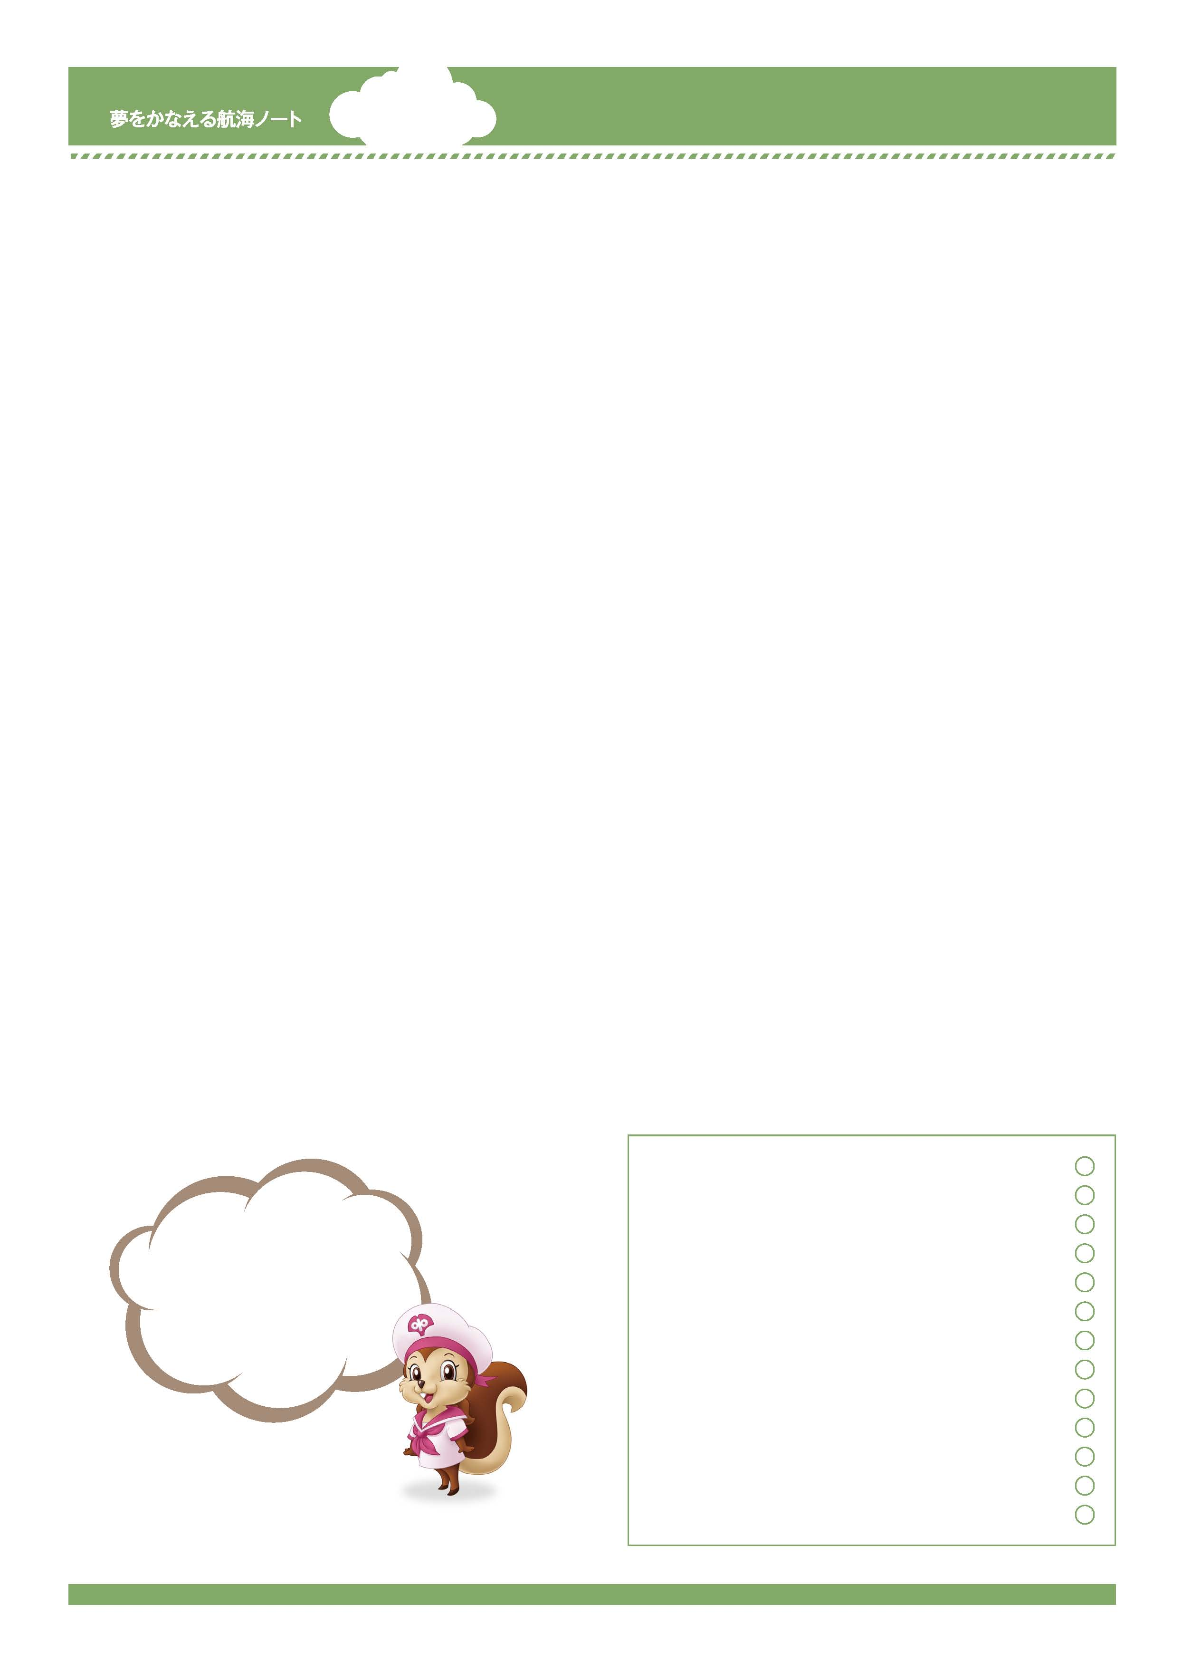
年 組 番

月 日
名前

2
自分の周りの
仕事を知ろう。
自分を磨こう。
職場体験は、仕事や職場について知ることができる絶好の機会だぞ。
どんな準備をしたらよいのか考えてみよう。
No.44-01
-------------------------------------------------------------------------------------------------------------------------------------------------------------------------------------------------------------------
-------------------------------------------------------------------------------------------------------------------------------------------------------------------------------------------------------------------
-------------------------------------------------------------------------------------------------------------------------------------------------------------------------------------------------------------------
-------------------------------------------------------------------------------------------------------------------------------------------------------------------------------------------------------------------
-------------------------------------------------------------------------------------------------------------------------------------------------------------------------------------------------------------------
-------------------------------------------------------------------------------------------------------------------------------------------------------------------------------------------------------------------
-------------------------------------------------------------------------------------------------------------------------------------------------------------------------------------------------------------------
「きちんとあいさつをする。」
「きちんと話をする。」
社会では当たり前のことだって
聞いたことがある。
職場体験の先輩の作文を聞いて、その感想を書きましょう。
-------------------------------------------------------------------------------------------------------------------------------------------------------------------------------------------------------------------
-------------------------------------------------------------------------------------------------------------------------------------------------------------------------------------------------------------------
私の考え
職場体験に向けて大切だと思うことは何ですか。
-------------------------------------------------------------------------------------------------------------------------------------------------------------------------------------------------------------------
班の子の考え
-------------------------------------------------------------------------------------------------------------------------------------------------------------------------------------------------------------------
学級の子の考え

-------------------------------------------------------------------------------------------------------------------------------------------------------------------------------------------------------------------
-------------------------------------------------------------------------------------------------------------------------------------------------------------------------------------------------------------------
-------------------------------------------------------------------------------------------------------------------------------------------------------------------------------------------------------------------
-------------------------------------------------------------------------------------------------------------------------------------------------------------------------------------------------------------------
-------------------------------------------------------------------------------------------------------------------------------------------------------------------------------------------------------------------
-------------------------------------------------------------------------------------------------------------------------------------------------------------------------------------------------------------------
-------------------------------------------------------------------------------------------------------------------------------------------------------------------------------------------------------------------
-------------------------------------------------------------------------------------------------------------------------------------------------------------------------------------------------------------------
-------------------------------------------------------------------------------------------------------------------------------------------------------------------------------------------------------------------
-------------------------------------------------------------------------------------------------------------------------------------------------------------------------------------------------------------------
-------------------------------------------------------------------------------------------------------------------------------------------------------------------------------------------------------------------
-------------------------------------------------------------------------------------------------------------------------------------------------------------------------------------------------------------------
-------------------------------------------------------------------------------------------------------------------------------------------------------------------------------------------------------------------
-------------------------------------------------------------------------------------------------------------------------------------------------------------------------------------------------------------------
「生き方メッセージ集」を見て、気づいたことをメモしましょう。
職場体験に向けてのわたしの決意
No.44-02
どんな職場体験をしたいのか、
前もってやりたいことを
決めておくといいわね。
-----------------------------------------------------------------------------------------------------------------------
-----------------------------------------------------------------------------------------------------------------------
-----------------------------------------------------------------------------------------------------------------------
-----------------------------------------------------------------------------------------------------------------------
-----------------------------------------------------------------------------------------------------------------------
先生から
-----------------------------------------------------------------------------------------------------------------------

