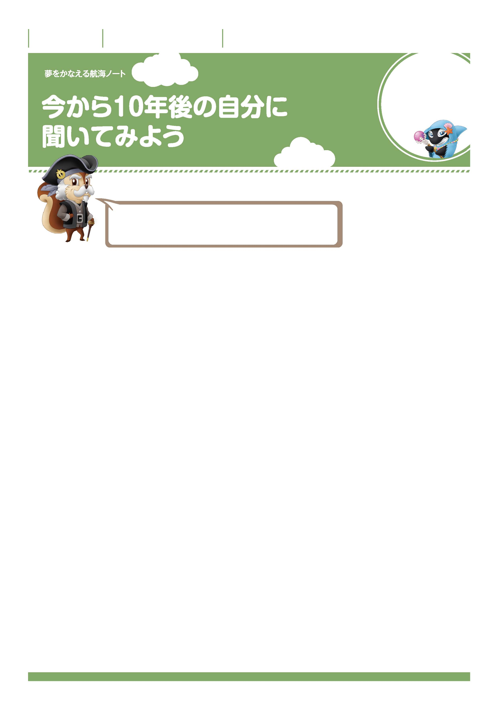

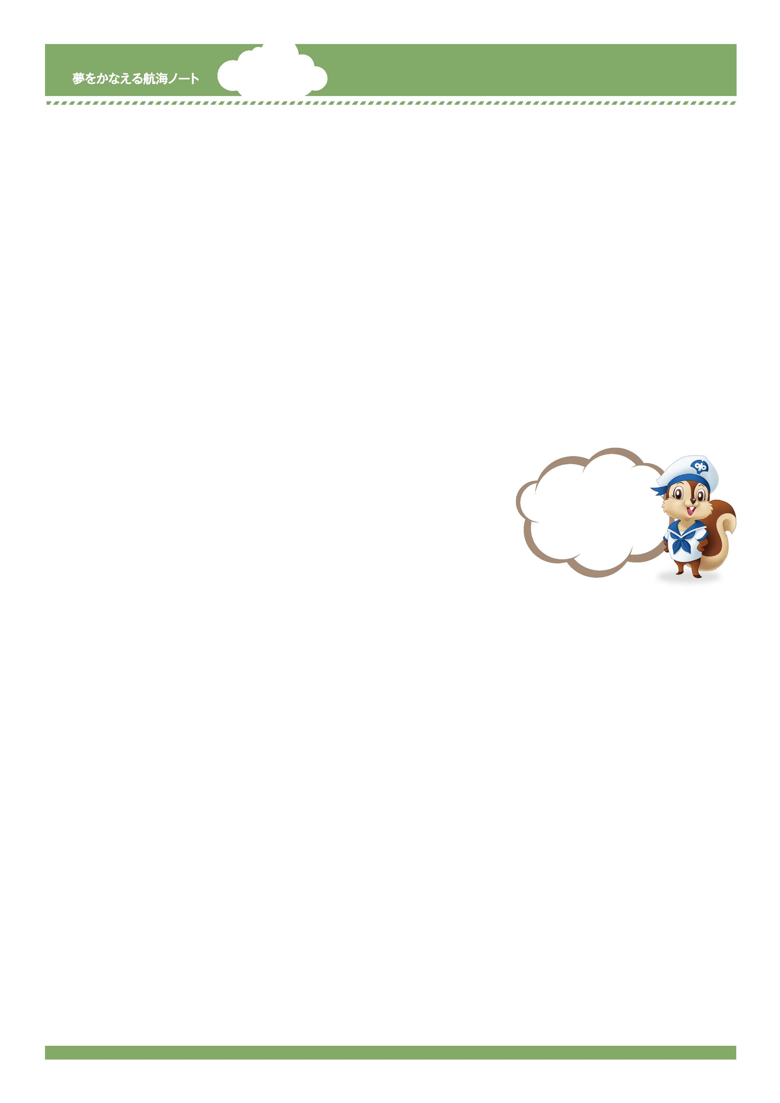
年 組 番

月 日
名前

2
自分を知り、
未来のなりたい自分を
かなえよう。
目の前のことも大切だけど、未来のきみを想像することも同じくらい大切だぞ。
なりたい自分がいて、その思いをかなえるために、
「今、何をするべきか。」が分かってくるんだ。
-------------------------------------------------------------------------------------------------------------------------------------------------------------------------------------------------------------------
-------------------------------------------------------------------------------------------------------------------------------------------------------------------------------------------------------------------
No.46-01
-------------------------------------------------------------------------------------------------------------------------------------------------------------------------------------------------------------------
-------------------------------------------------------------------------------------------------------------------------------------------------------------------------------------------------------------------
10年後のきみが、目の前にいます。
10年後の自分に次の質問をしたら、10年後のきみは何と答えるでしょうか。
10年後の自分になったつもりで答えましょう。
友達の答えを聞いての感想
今、どこにいますか？
-------------------------------------------------------------------------------------------------------------------------------------------------------------------------------------------------------------------
-------------------------------------------------------------------------------------------------------------------------------------------------------------------------------------------------------------------
質問１
-------------------------------------------------------------------------------------------------------------------------------------------------------------------------------------------------------------------
-------------------------------------------------------------------------------------------------------------------------------------------------------------------------------------------------------------------
友達の答えを聞いての感想

今、何をしていますか。（学生、職業など）
-------------------------------------------------------------------------------------------------------------------------------------------------------------------------------------------------------------------
-------------------------------------------------------------------------------------------------------------------------------------------------------------------------------------------------------------------
質問2
-------------------------------------------------------------------------------------------------------------------------------------------------------------------------------------------------------------------
-------------------------------------------------------------------------------------------------------------------------------------------------------------------------------------------------------------------
友達の答えを聞いての感想

今、一番興味をもっていることは何ですか。
-------------------------------------------------------------------------------------------------------------------------------------------------------------------------------------------------------------------
-------------------------------------------------------------------------------------------------------------------------------------------------------------------------------------------------------------------
質問3
-------------------------------------------------------------------------------------------------------------------------------------------------------------------------------------------------------------------
-------------------------------------------------------------------------------------------------------------------------------------------------------------------------------------------------------------------
友達の答えを聞いての感想

子どものころの夢で実現したことはありますか。
質問4

No.46-02
-------------------------------------------------------------------------------------------------------------------------------------------------------------------------------------------------------------------
-------------------------------------------------------------------------------------------------------------------------------------------------------------------------------------------------------------------
目標をもって
今後の生活を送ることが
大切なんだね。
-------------------------------------------------------------------------------------------------------------------------------------------------------------------------------------------------------------------
-------------------------------------------------------------------------------------------------------------------------------------------------------------------------------------------------------------------
友達の答えを聞いての感想

今、一番やらなければならないことは何ですか。
-------------------------------------------------------------------------------------------------------------------------------------------------------------------------------------------------------------------
-------------------------------------------------------------------------------------------------------------------------------------------------------------------------------------------------------------------
質問5
-------------------------------------------------------------------------------------------------------------------------------------------------------------------------------------------------------------------
-------------------------------------------------------------------------------------------------------------------------------------------------------------------------------------------------------------------
友達の答えを聞いての感想

毎日は楽しいですか。
質問6
自分の向上のために努力していることや努力したいことを入れて、感想を書きましょう。
-------------------------------------------------------------------------------------------------------------------------------------------------------------------------------------------------------------------
-------------------------------------------------------------------------------------------------------------------------------------------------------------------------------------------------------------------
-------------------------------------------------------------------------------------------------------------------------------------------------------------------------------------------------------------------
-------------------------------------------------------------------------------------------------------------------------------------------------------------------------------------------------------------------
-------------------------------------------------------------------------------------------------------------------------------------------------------------------------------------------------------------------
-------------------------------------------------------------------------------------------------------------------------------------------------------------------------------------------------------------------
-------------------------------------------------------------------------------------------------------------------------------------------------------------------------------------------------------------------
-------------------------------------------------------------------------------------------------------------------------------------------------------------------------------------------------------------------
-------------------------------------------------------------------------------------------------------------------------------------------------------------------------------------------------------------------
-------------------------------------------------------------------------------------------------------------------------------------------------------------------------------------------------------------------
-------------------------------------------------------------------------------------------------------------------------------------------------------------------------------------------------------------------
-------------------------------------------------------------------------------------------------------------------------------------------------------------------------------------------------------------------
-------------------------------------------------------------------------------------------------------------------------------------------------------------------------------------------------------------------
-------------------------------------------------------------------------------------------------------------------------------------------------------------------------------------------------------------------
-------------------------------------------------------------------------------------------------------------------------------------------------------------------------------------------------------------------
-------------------------------------------------------------------------------------------------------------------------------------------------------------------------------------------------------------------
-------------------------------------------------------------------------------------------------------------------------------------------------------------------------------------------------------------------

