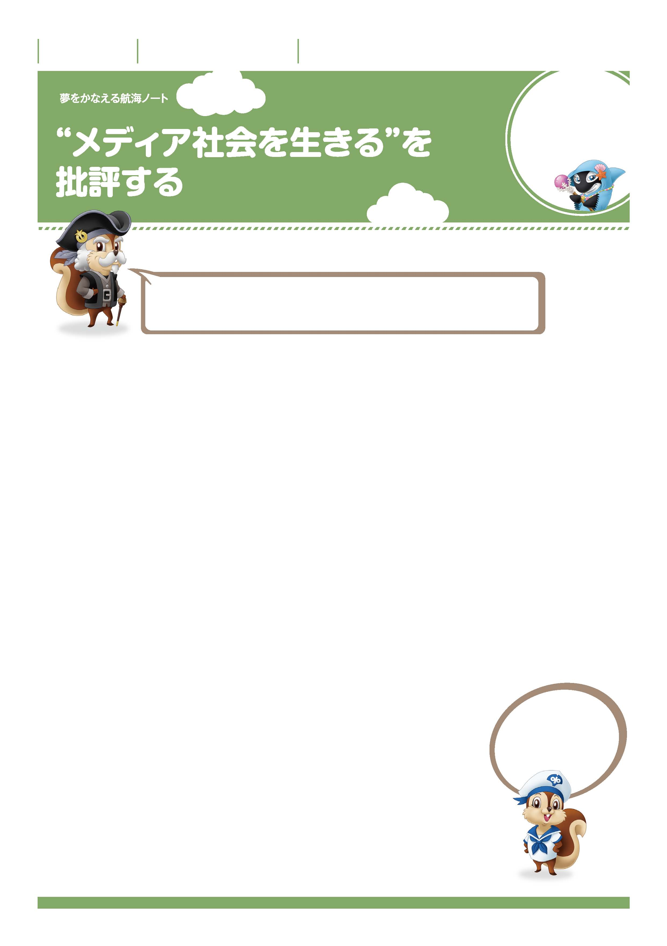

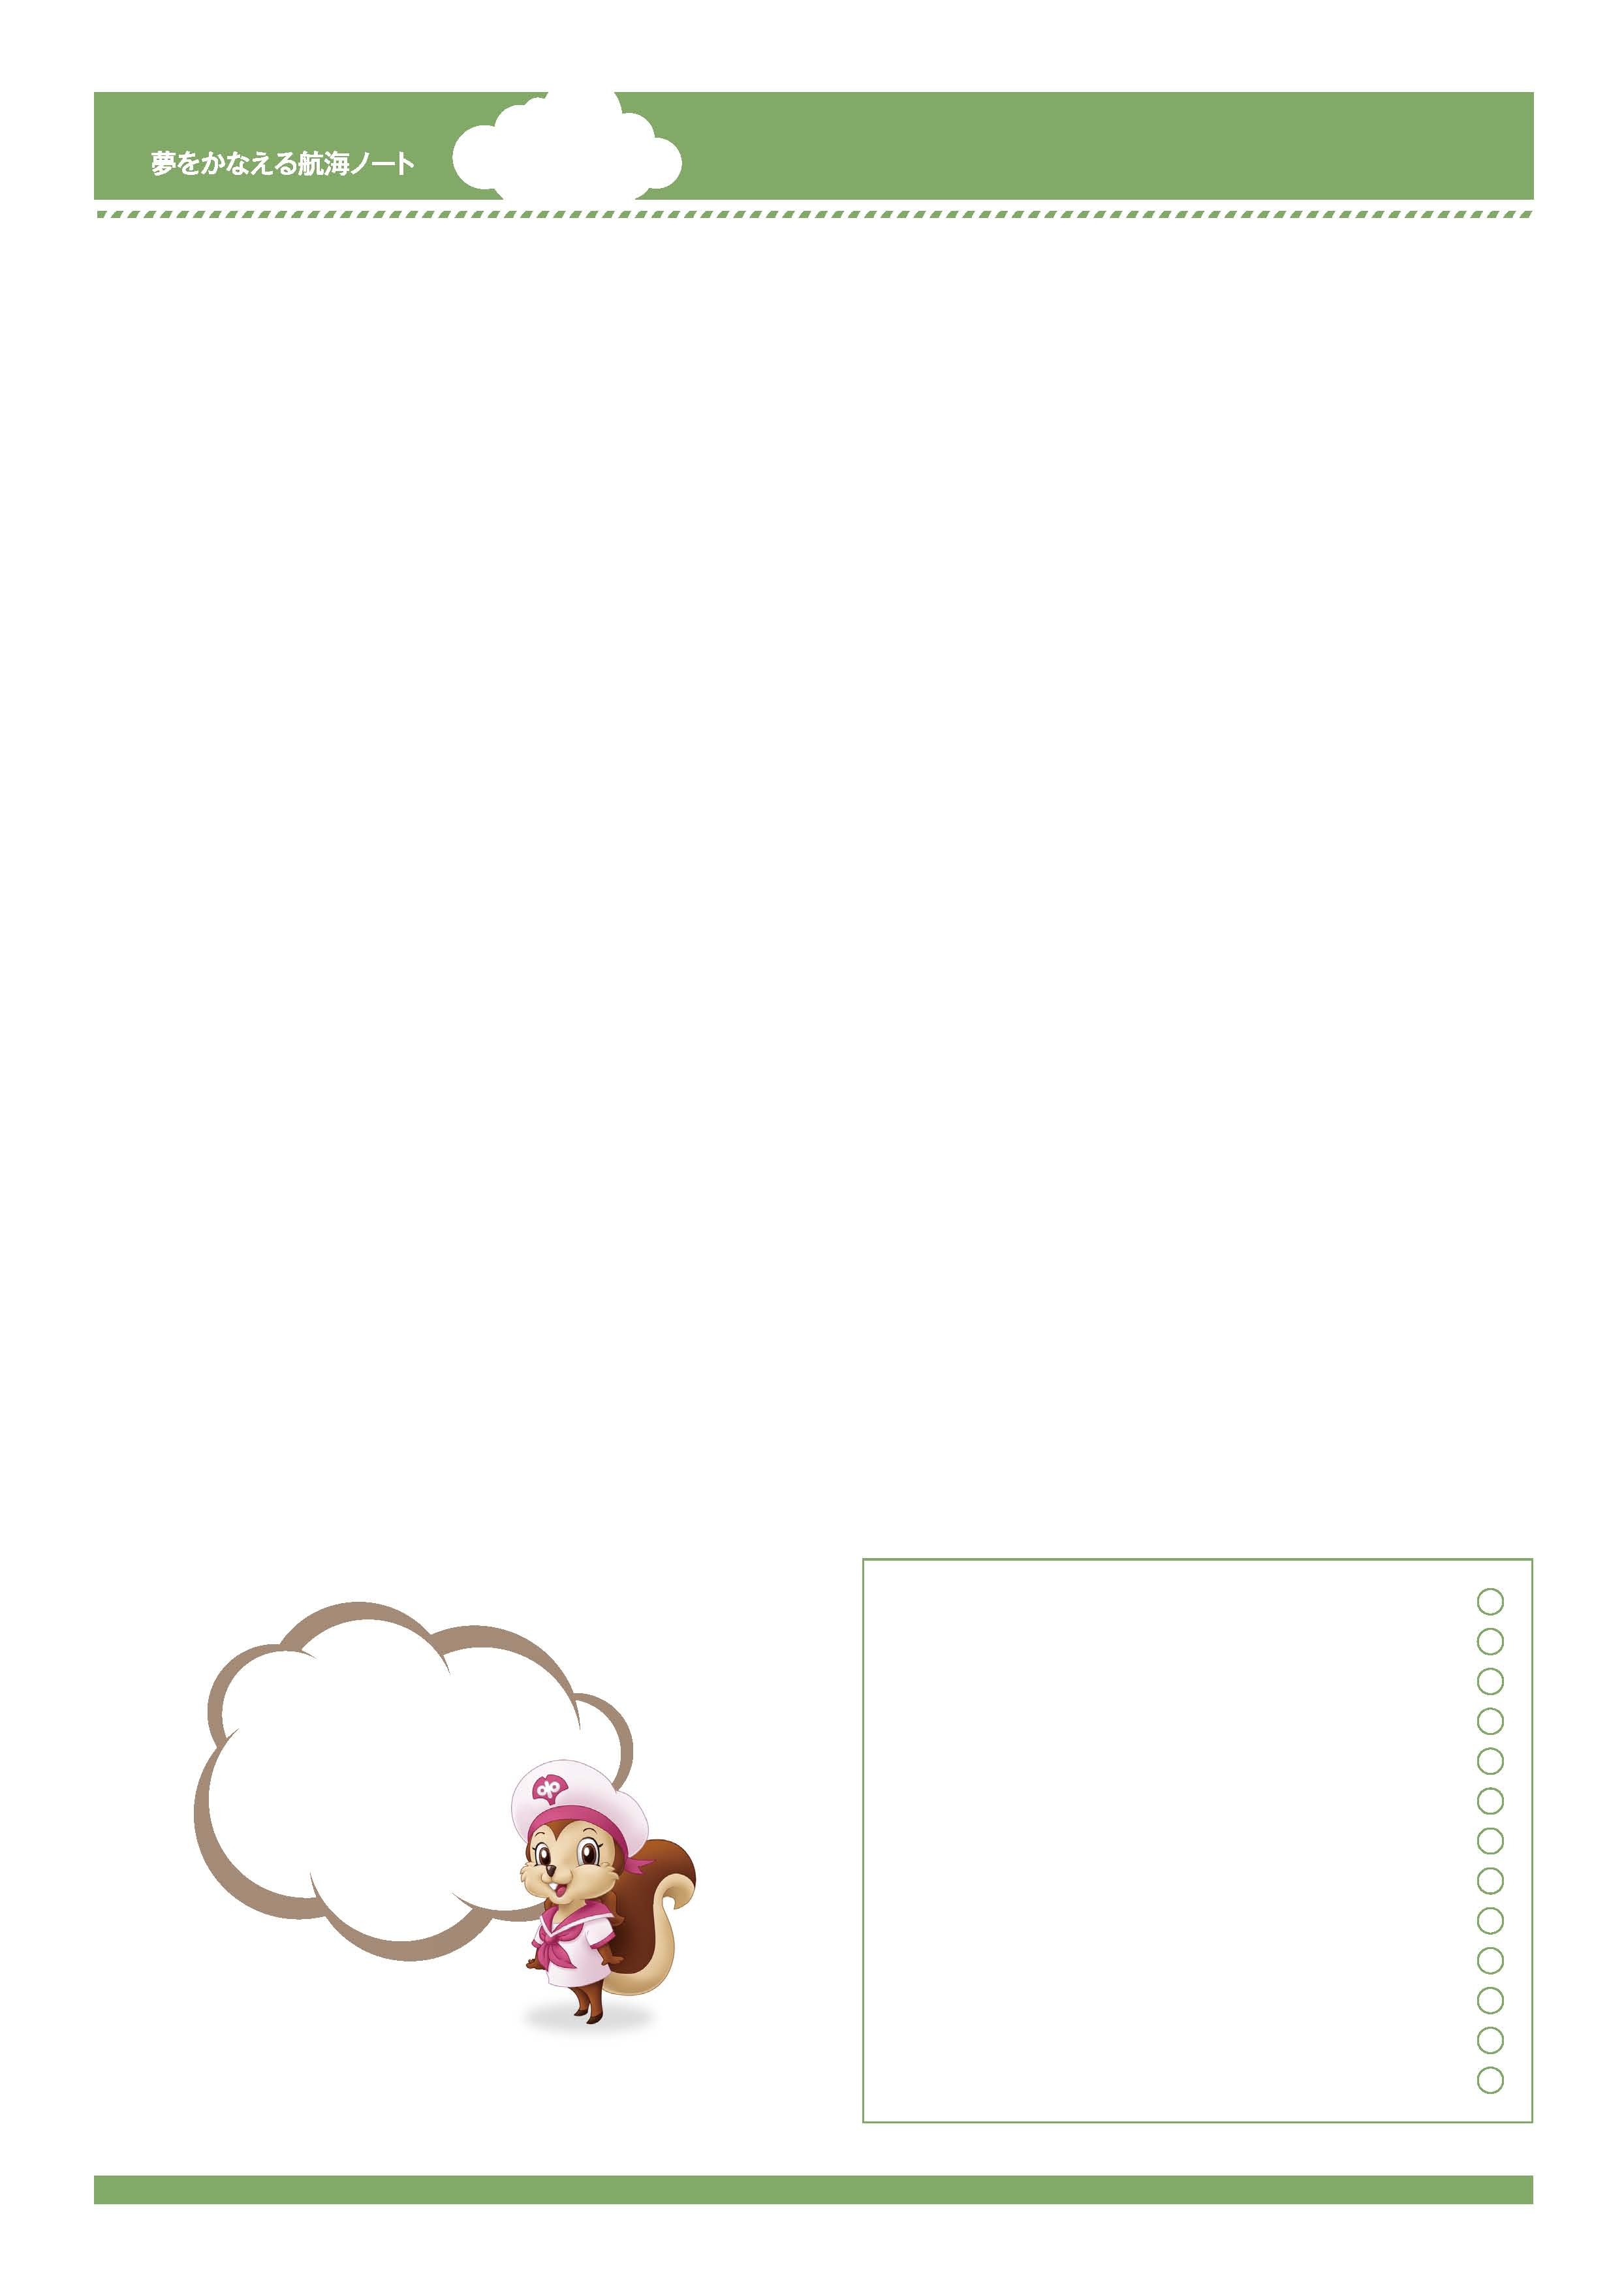
年 組 番

月 日
名前

3
読んで、考えて、
自分の意見を
まとめよう。
本を読んで、筆者の考えにふれることはすばらしいことだね。
そして、きみ自身が、筆者の考えに対してどう思うかをきちんとまとめ、
伝えることはとても大切なことなんだ。
No.50-01
-------------------------------------------------------------------------------------------------------------------------------------------------------------------------------------------------------------------
-------------------------------------------------------------------------------------------------------------------------------------------------------------------------------------------------------------------
-------------------------------------------------------------------------------------------------------------------------------------------------------------------------------------------------------------------
-------------------------------------------------------------------------------------------------------------------------------------------------------------------------------------------------------------------
説明文を読んだ感想を書きましょう。
-------------------------------------------------------------------------------------------------------------------------------------------------------------------------------------------------------------------
-------------------------------------------------------------------------------------------------------------------------------------------------------------------------------------------------------------------
-------------------------------------------------------------------------------------------------------------------------------------------------------------------------------------------------------------------
-------------------------------------------------------------------------------------------------------------------------------------------------------------------------------------------------------------------
-------------------------------------------------------------------------------------------------------------------------------------------------------------------------------------------------------------------
-------------------------------------------------------------------------------------------------------------------------------------------------------------------------------------------------------------------
-------------------------------------------------------------------------------------------------------------------------------------------------------------------------------------------------------------------
-------------------------------------------------------------------------------------------------------------------------------------------------------------------------------------------------------------------
-------------------------------------------------------------------------------------------------------------------------------------------------------------------------------------------------------------------
-------------------------------------------------------------------------------------------------------------------------------------------------------------------------------------------------------------------
-------------------------------------------------------------------------------------------------------------------------------------------------------------------------------------------------------------------
批評文を読んで、説明文との違いについて気づいたことをできるだけたくさん書きましょう。
筆者の考えが書かれていて、
参考になったよ。

-------------------------------------------------------------------------------------------------------------------------------------------------------------------------------------------------------------------
-------------------------------------------------------------------------------------------------------------------------------------------------------------------------------------------------------------------
-------------------------------------------------------------------------------------------------------------------------------------------------------------------------------------------------------------------
-------------------------------------------------------------------------------------------------------------------------------------------------------------------------------------------------------------------
-------------------------------------------------------------------------------------------------------------------------------------------------------------------------------------------------------------------
-------------------------------------------------------------------------------------------------------------------------------------------------------------------------------------------------------------------
-------------------------------------------------------------------------------------------------------------------------------------------------------------------------------------------------------------------
批評文は説明文に比べて、読み手にどんな印象を与えますか。
No.50-02
-------------------------------------------------------------------------------------------------------------------------------------------------------------------------------------------------------------------
-------------------------------------------------------------------------------------------------------------------------------------------------------------------------------------------------------------------
-------------------------------------------------------------------------------------------------------------------------------------------------------------------------------------------------------------------
-------------------------------------------------------------------------------------------------------------------------------------------------------------------------------------------------------------------
-------------------------------------------------------------------------------------------------------------------------------------------------------------------------------------------------------------------
-------------------------------------------------------------------------------------------------------------------------------------------------------------------------------------------------------------------
-------------------------------------------------------------------------------------------------------------------------------------------------------------------------------------------------------------------
「メディア社会を生きる」の批評文を書きましょう。
「ここは賛成だ。」、
「ここはちょっと違う。」、
というように自分の考えを
まとめながら
読むことが大切ね。
-----------------------------------------------------------------------------------------------------------------------
-----------------------------------------------------------------------------------------------------------------------
-----------------------------------------------------------------------------------------------------------------------
-----------------------------------------------------------------------------------------------------------------------
-----------------------------------------------------------------------------------------------------------------------
先生から
-----------------------------------------------------------------------------------------------------------------------

