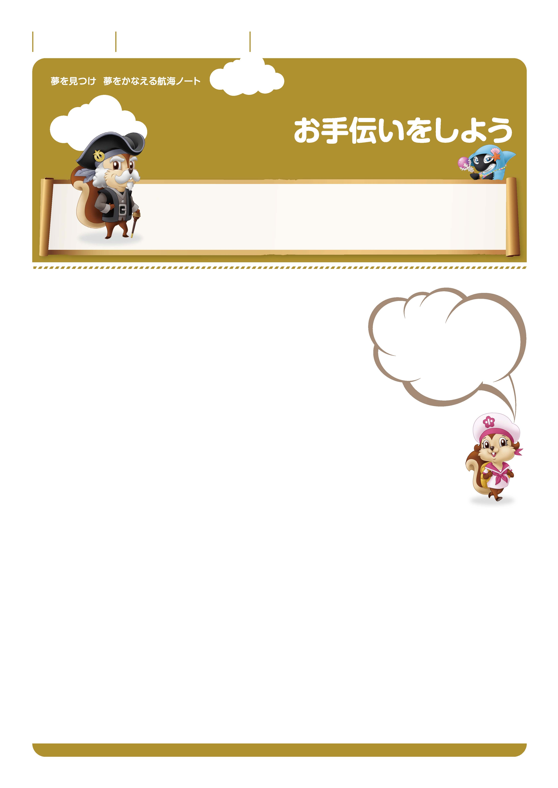

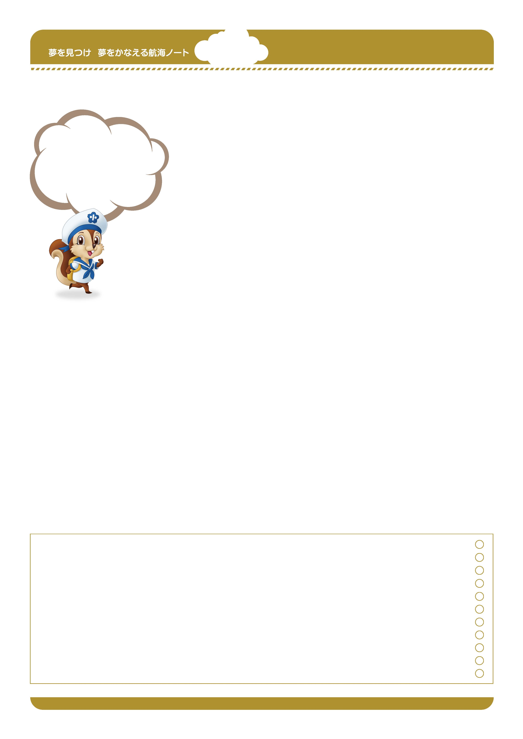
月 日
年 組 番
名前

自分の役割、言われたことを、しっかり成し遂げる。
お手伝いって、まるで社会に出てからの仕事みたいなんだ。
一人一人が大きな責任を負っているから、できたときにたくさんほめられるんだよ。
今までどんなお手伝いをしましたか。
私はお母さんのお料理のお手伝い。
お鍋でコトコト煮ている野菜などを
時々かき混ぜていたわ。
そのとき、どんな気持ちがしましたか。
---------------------------------------------------------------------------------------------------------------------------------------------------------------------------------------------------------------------------------------------
–-
---------------------------------------------------------------------------------------------------------------------------------------------------------------------------------------------------------------------------------------------
–-
---------------------------------------------------------------------------------------------------------------------------------------------------------------------------------------------------------------------------------------------
–-
---------------------------------------------------------------------------------------------------------------------------------------------------------------------------------------------------------------------------------------------
–-
---------------------------------------------------------------------------------------------------------------------------------------------------------------------------------------------------------------------------------------------
–-
---------------------------------------------------------------------------------------------------------------------------------------------------------------------------------------------------------------------------------------------
–-
---------------------------------------------------------------------------------------------------------------------------------------------------------------------------------------------------------------------------------------------
–-
---------------------------------------------------------------------------------------------------------------------------------------------------------------------------------------------------------------------------------------------
–-

---------------------------------------------------------------------------------------------------------------------------------------------------------------------------------------------------------------------------------------------
–-
---------------------------------------------------------------------------------------------------------------------------------------------------------------------------------------------------------------------------------------------
–-
キャプテン アイリスの
お手伝いで、
毎朝天気を確かめること。
１日の予定を決めるために、
大切な役割なんだよ。
今、どんなお手伝いをしていますか。
---------------------------------------------------------------------------------------------------------------------------------------------------------------------------------------------------------------------------------------------
–-
---------------------------------------------------------------------------------------------------------------------------------------------------------------------------------------------------------------------------------------------
–-
---------------------------------------------------------------------------------------------------------------------------------------------------------------------------------------------------------------------------------------------
–-
家族の方から、どんなことを言われますか。
---------------------------------------------------------------------------------------------------------------------------------------------------------------------------------------------------------------------------------------------
–-
これから挑戦したいお手伝いはなんですか。
---------------------------------------------------------------------------------------------------------------------------------------------------------------------------------------------------------------------------------------------
–-
---------------------------------------------------------------------------------------------------------------------------------------------------------------------------------------------------------------------------------------------
–-
---------------------------------------------------------------------------------------------------------------------------------------------------------------------------------------------------------------------------------------------
–-
その理由は何ですか。
---------------------------------------------------------------------------------------------------------------------------------------------------------------------------------------------------------------------------------------------
–-
---------------------------------------------------------------------------------------------------------------------------------------------------------------------------------------------------------------------------------------------
–-
---------------------------------------------------------------------------------------------------------------------------------------------------------------------------------------------------------------------------------------------
–-
先生から
-----------------------------------------------------------------------------------------------------------------------
-----------------------------------------------------------------------------------------------------------------------
-----------------------------------------------------------------------------------------------------------------------
保護者の方から

-----------------------------------------------------------------------------------------------------------------------
-----------------------------------------------------------------------------------------------------------------------
-----------------------------------------------------------------------------------------------------------------------
-----------------------------------------------------------------------------------------------------------------------
-----------------------------------------------------------------------------------------------------------------------
-----------------------------------------------------------------------------------------------------------------------
-----------------------------------------------------------------------------------------------------------------------

---------------------------------------------------------------------------------------------------------------------------------------------------------------------------------------------------------------------------------------------
–-
---------------------------------------------------------------------------------------------------------------------------------------------------------------------------------------------------------------------------------------------
–-
---------------------------------------------------------------------------------------------------------------------------------------------------------------------------------------------------------------------------------------------
–-
---------------------------------------------------------------------------------------------------------------------------------------------------------------------------------------------------------------------------------------------
–-
---------------------------------------------------------------------------------------------------------------------------------------------------------------------------------------------------------------------------------------------
–-
---------------------------------------------------------------------------------------------------------------------------------------------------------------------------------------------------------------------------------------------
–-
---------------------------------------------------------------------------------------------------------------------------------------------------------------------------------------------------------------------------------------------
–-
---------------------------------------------------------------------------------------------------------------------------------------------------------------------------------------------------------------------------------------------
–-

