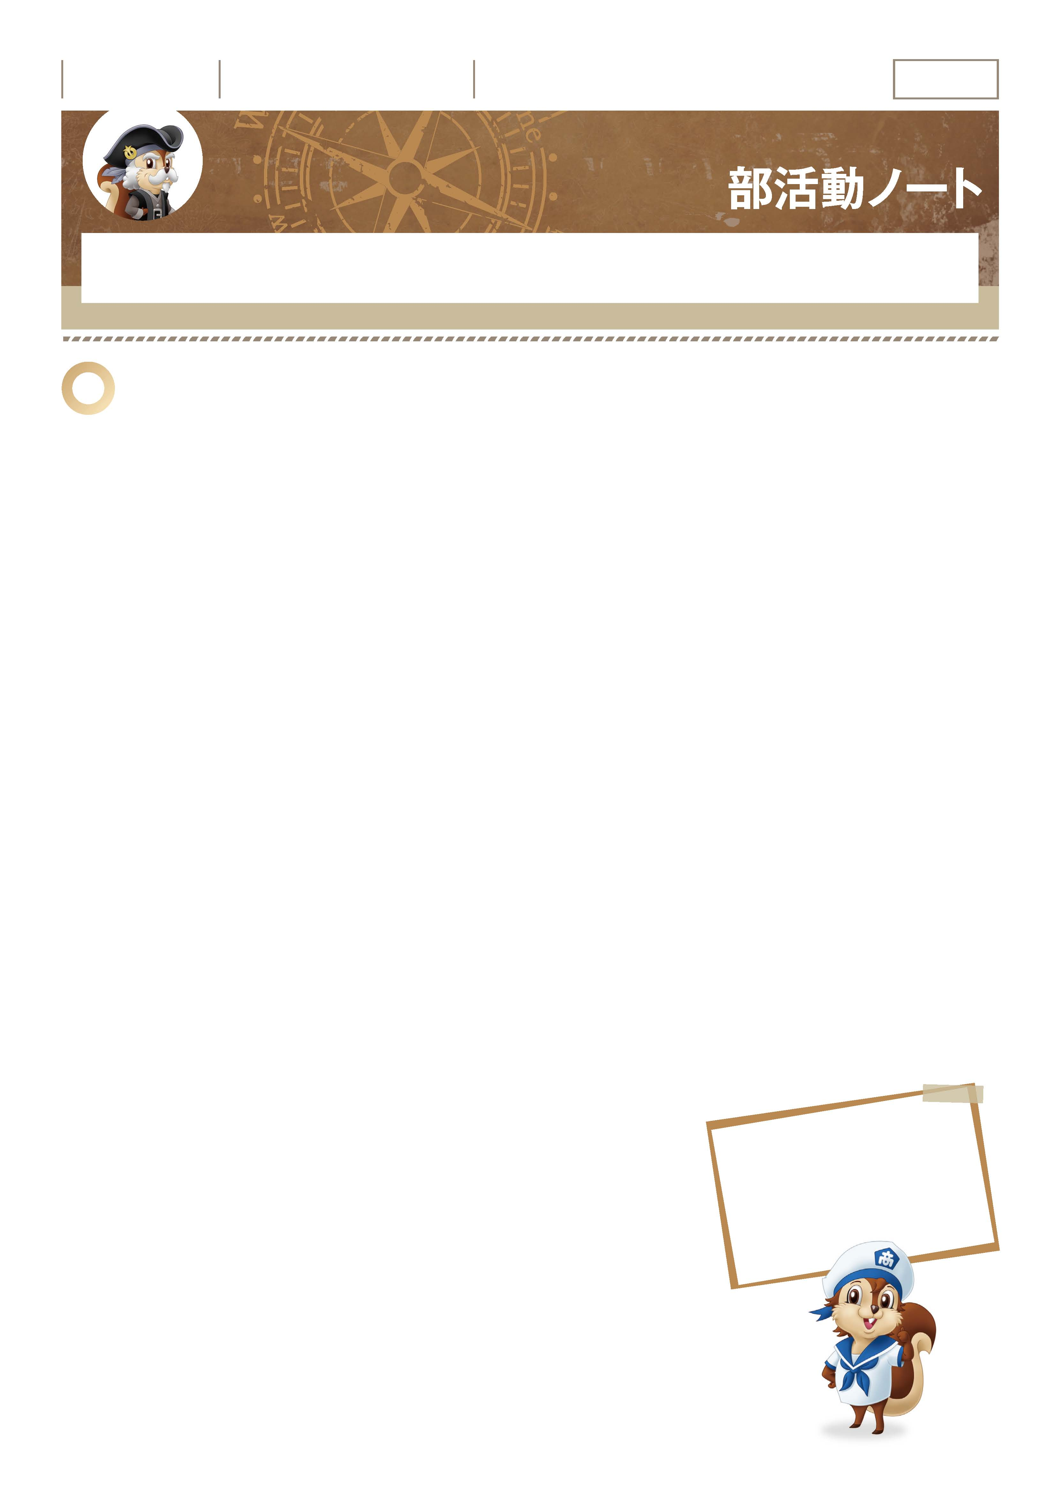
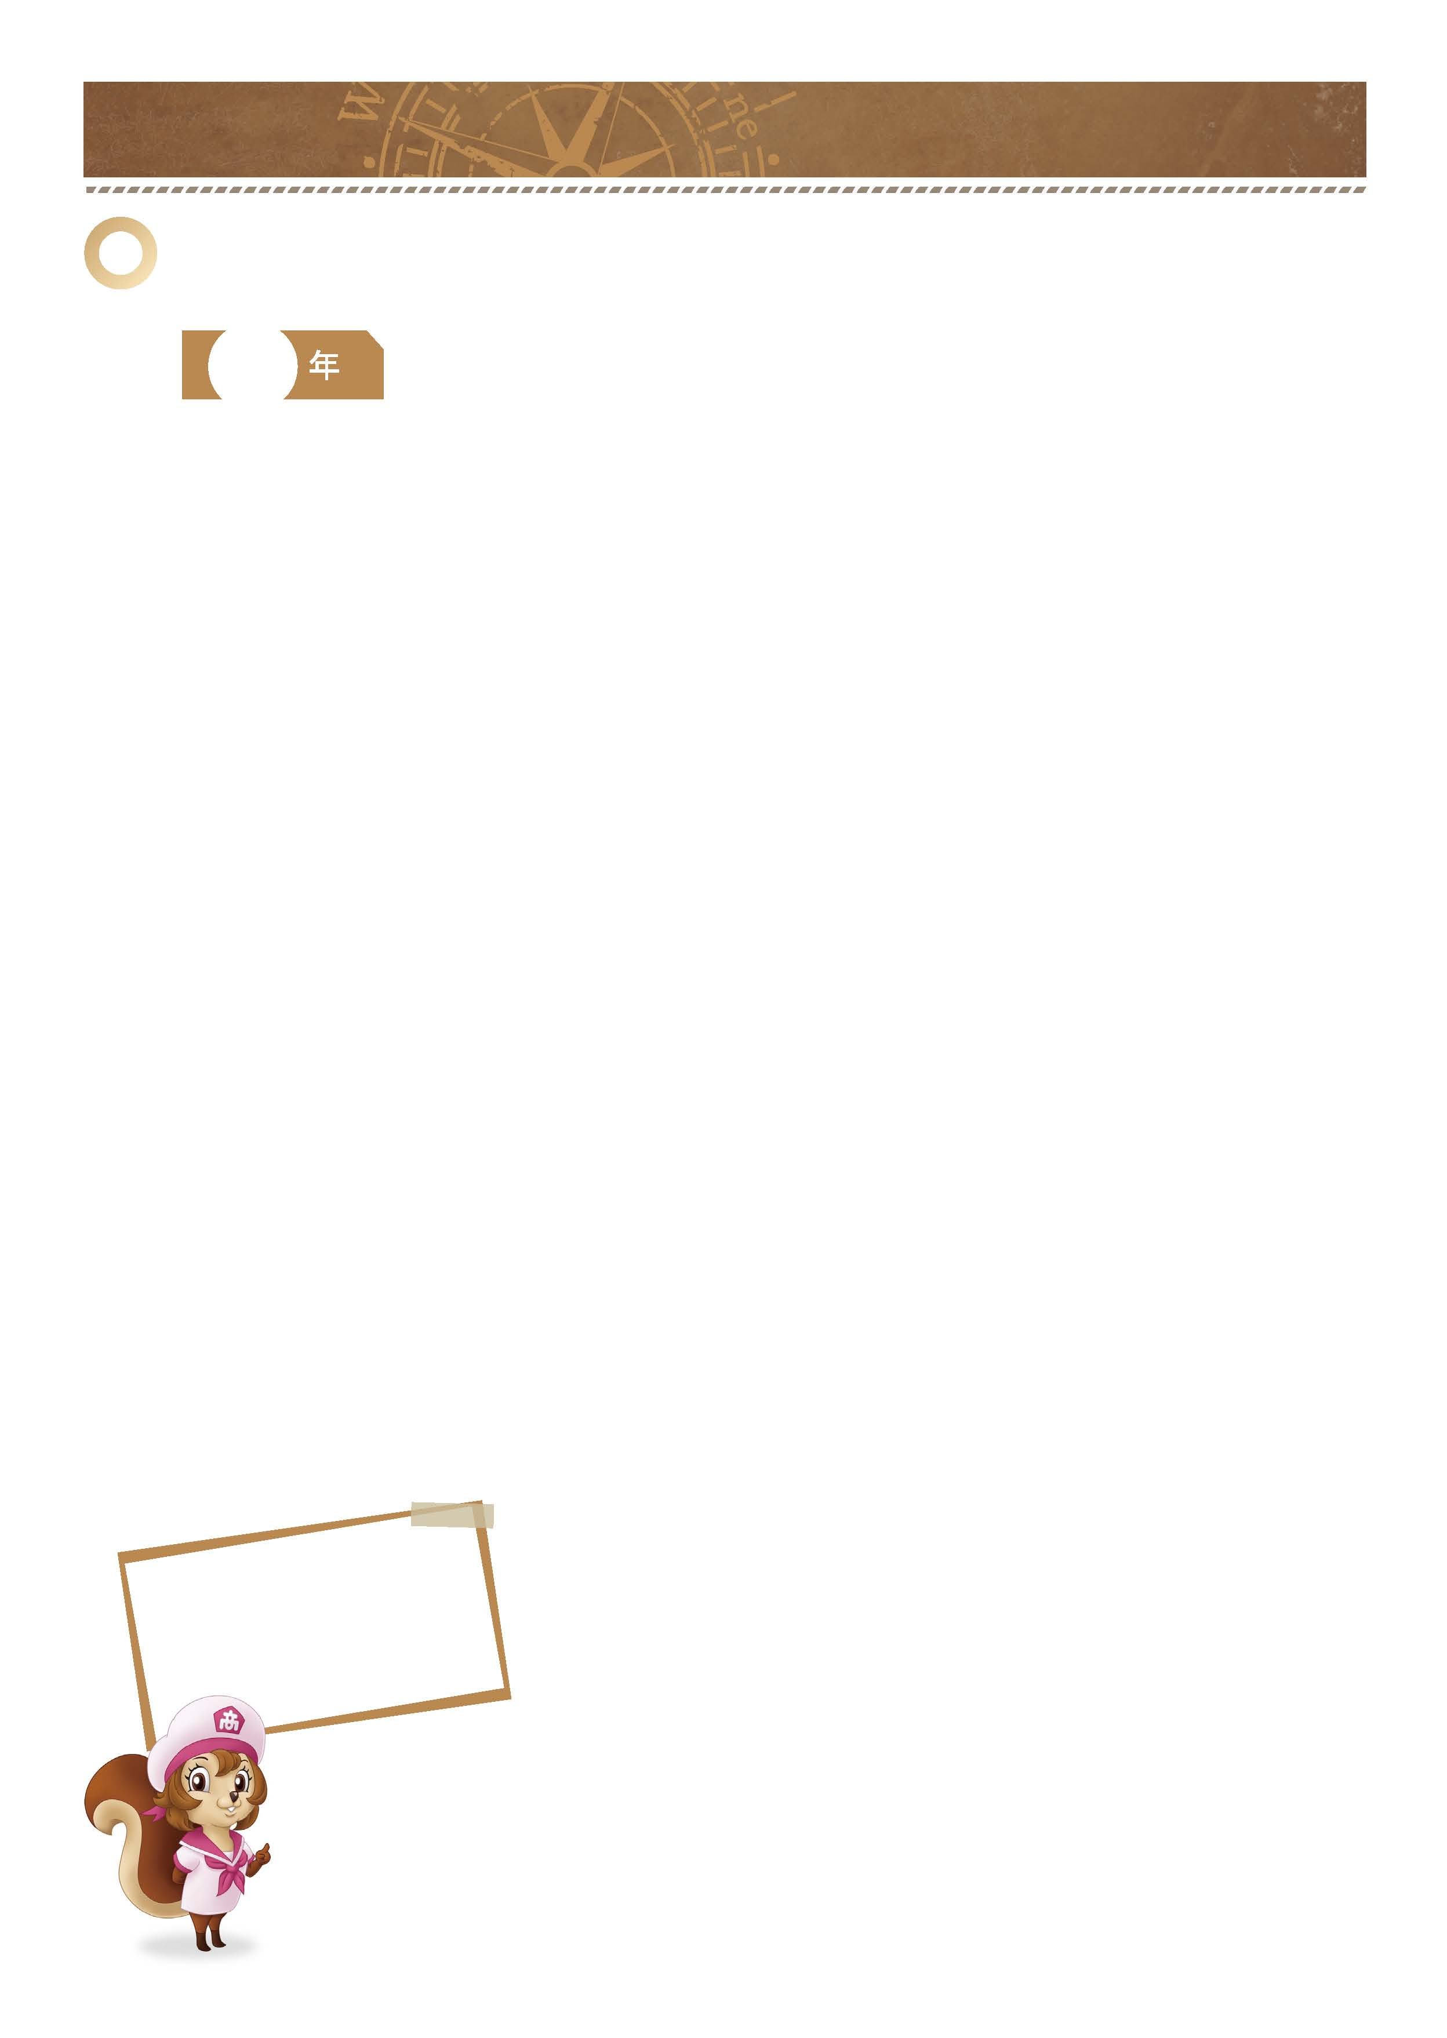
年 組 番

月 日
「仲間たちと目標に向かって努力しよう。」
｜ 部活動ノート ｜ No.02-01
同じ目標をもつ仲間たちと切磋琢磨する、特技や興味を伸ばす、部活動に真剣に取り組むことは自分を大きく成長させてくれます。
ぜひ真剣に取り組んでみましょう。
名前

1
入る部活動を決めたら3年間の目標を立てましょう。
確 認 欄

-------------------------------------------------------------------------------------------------------------------------------------------------------------------------------------------------------------------
■入部の動機は何ですか。
-------------------------------------------------------------------------------------------------------------------------------------------------------------------------------------------------------------------
-------------------------------------------------------------------------------------------------------------------------------------------------------------------------------------------------------------------
-------------------------------------------------------------------------------------------------------------------------------------------------------------------------------------------------------------------
■部活名
-------------------------------------------------------------------------------------------------------------------------------------------------------------------------------------------------------------------
■ 3年間の目標は何ですか。
-------------------------------------------------------------------------------------------------------------------------------------------------------------------------------------------------------------------
-------------------------------------------------------------------------------------------------------------------------------------------------------------------------------------------------------------------
-------------------------------------------------------------------------------------------------------------------------------------------------------------------------------------------------------------------
-------------------------------------------------------------------------------------------------------------------------------------------------------------------------------------------------------------------
-------------------------------------------------------------------------------------------------------------------------------------------------------------------------------------------------------------------
-------------------------------------------------------------------------------------------------------------------------------------------------------------------------------------------------------------------
-------------------------------------------------------------------------------------------------------------------------------------------------------------------------------------------------------------------
-------------------------------------------------------------------------------------------------------------------------------------------------------------------------------------------------------------------
-------------------------------------------------------------------------------------------------------------------------------------------------------------------------------------------------------------------
-------------------------------------------------------------------------------------------------------------------------------------------------------------------------------------------------------------------
-------------------------------------------------------------------------------------------------------------------------------------------------------------------------------------------------------------------
-------------------------------------------------------------------------------------------------------------------------------------------------------------------------------------------------------------------
■部活動を通して身に付けたいことは何ですか。
中学と同じことを続けて
もっと上をめざすのもいいけど、
新しいことを
始めてみたい気もするな。

-------------------------------------------------------------------------------------------------------------------------------------------------------------------------------------------------------------------
-------------------------------------------------------------------------------------------------------------------------------------------------------------------------------------------------------------------
-------------------------------------------------------------------------------------------------------------------------------------------------------------------------------------------------------------------
-------------------------------------------------------------------------------------------------------------------------------------------------------------------------------------------------------------------
-------------------------------------------------------------------------------------------------------------------------------------------------------------------------------------------------------------------
-------------------------------------------------------------------------------------------------------------------------------------------------------------------------------------------------------------------
-------------------------------------------------------------------------------------------------------------------------------------------------------------------------------------------------------------------

今年の自分に
足りなかったものは何だろう。
それを克服するには
どうすればよいか考えよう。

■今年の記録（大会やコンクールなどの記録）
-------------------------------------------------------------------------------------------------------------------------------------------------------------------------------------------------------------------
■本年度の反省と次年度の目標を書きましょう。
-------------------------------------------------------------------------------------------------------------------------------------------------------------------------------------------------------------------
-------------------------------------------------------------------------------------------------------------------------------------------------------------------------------------------------------------------
-------------------------------------------------------------------------------------------------------------------------------------------------------------------------------------------------------------------
-------------------------------------------------------------------------------------------------------------------------------------------------------------------------------------------------------------------
-------------------------------------------------------------------------------------------------------------------------------------------------------------------------------------------------------------------
［記入例］ 日程／○月○日（○）〜○月○日（○） 大会名／愛知県高等学校野球選手権大会 成績／地区予選3位

｜ 部活動ノート ｜ No.02-02
2
今年の目標を設定し、大会やコンクールなどの記録、自分自身の成長の記録を記入していきましょう。
また、年度末に振り返ってみましょう。

-------------------------------------------------------------------------------------------------------------------------------------------------------------------------------------------------------------------
■今年の目標は何ですか。
-------------------------------------------------------------------------------------------------------------------------------------------------------------------------------------------------------------------
-------------------------------------------------------------------------------------------------------------------------------------------------------------------------------------------------------------------
-------------------------------------------------------------------------------------------------------------------------------------------------------------------------------------------------------------------
-------------------------------------------------------------------------------------------------------------------------------------------------------------------------------------------------------------------
-------------------------------------------------------------------------------------------------------------------------------------------------------------------------------------------------------------------
-------------------------------------------------------------------------------------------------------------------------------------------------------------------------------------------------------------------
■そのために必要なことは何ですか。
-------------------------------------------------------------------------------------------------------------------------------------------------------------------------------------------------------------------
-------------------------------------------------------------------------------------------------------------------------------------------------------------------------------------------------------------------
-------------------------------------------------------------------------------------------------------------------------------------------------------------------------------------------------------------------
-------------------------------------------------------------------------------------------------------------------------------------------------------------------------------------------------------------------
-------------------------------------------------------------------------------------------------------------------------------------------------------------------------------------------------------------------
-------------------------------------------------------------------------------------------------------------------------------------------------------------------------------------------------------------------
-------------------------------------------------------------------------------------------------------------------------------------------------------------------------------------------------------------------

