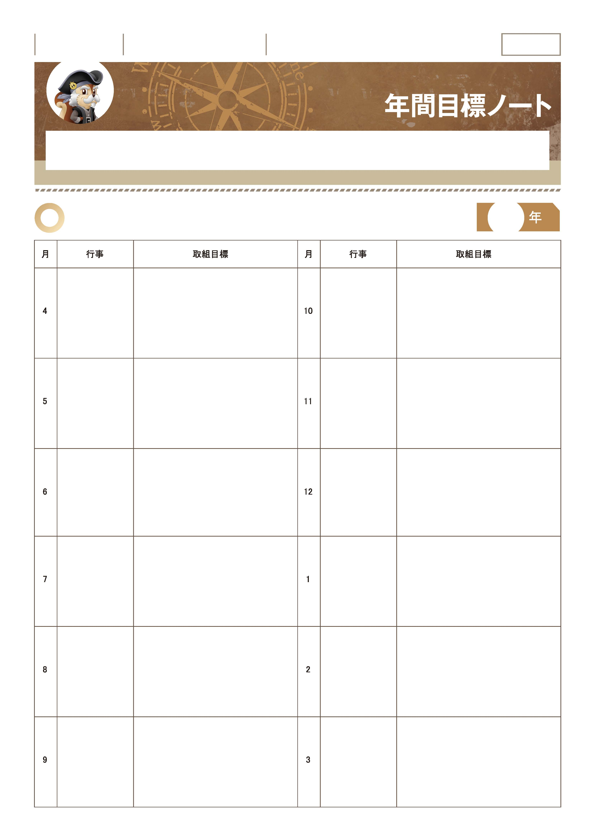

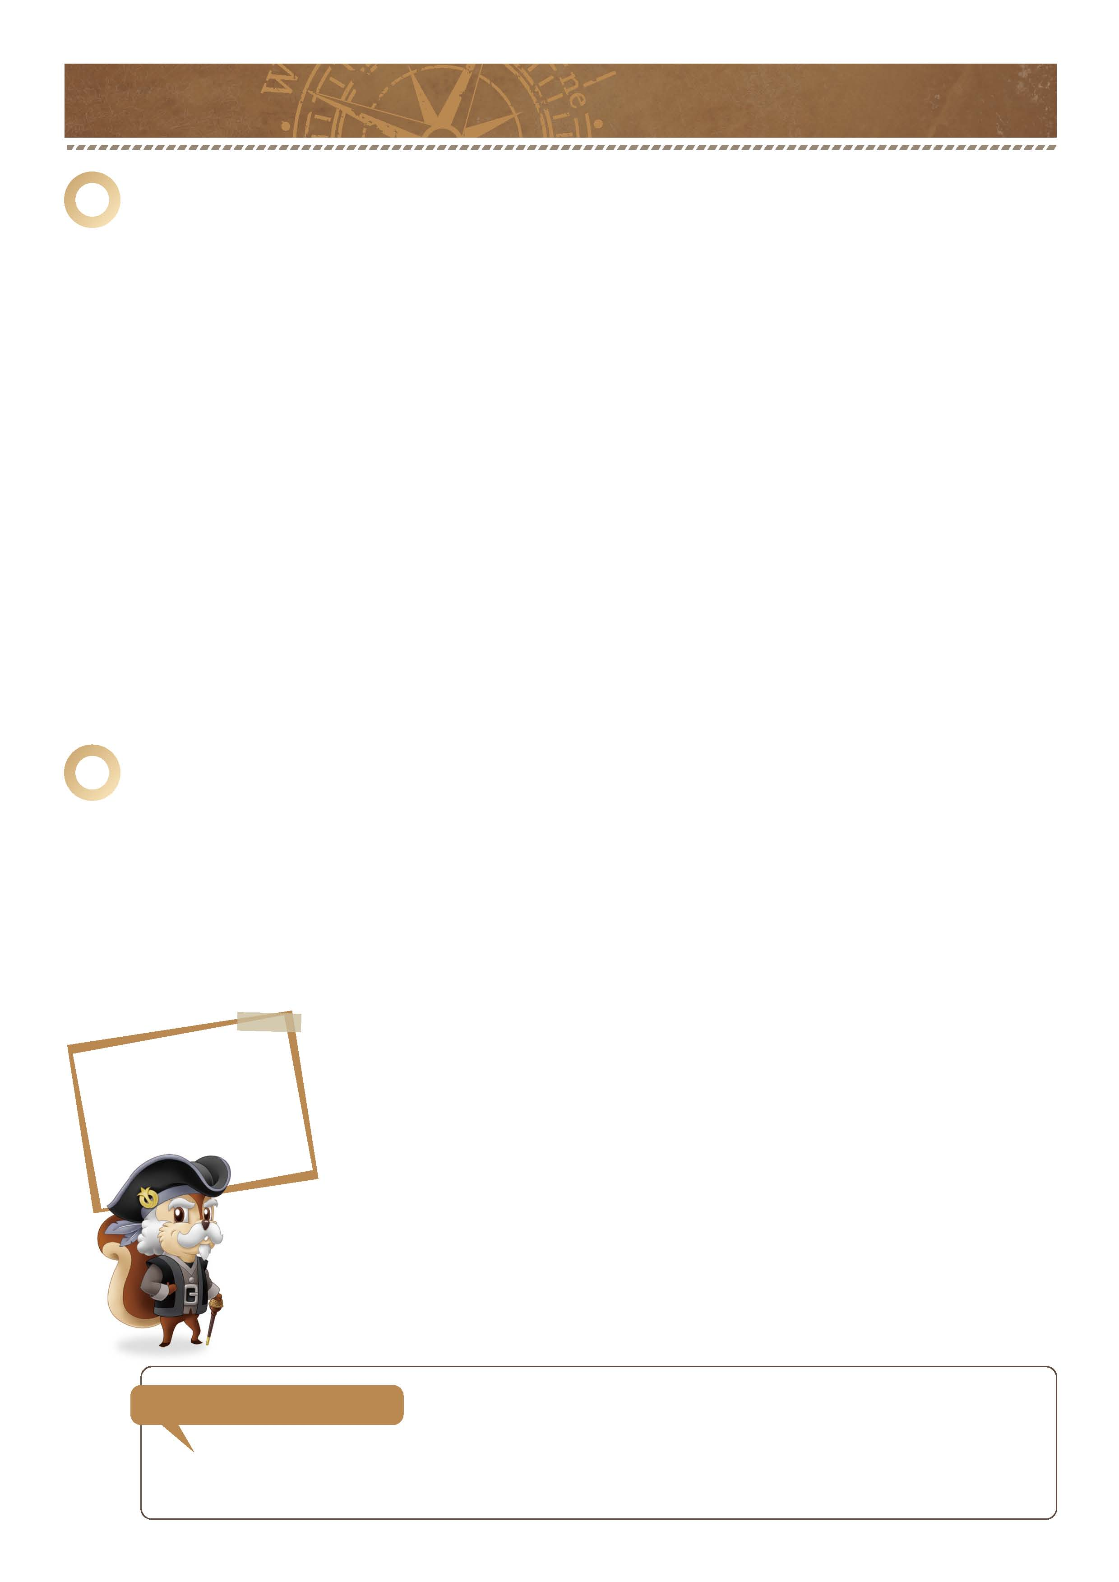
「夢に向かって1年をスタートしよう。」

｜ 年間目標ノート ｜ No.09-01

さあ1年の始まり。最初に今年の学校行事などを確認しましょう。
そして改めて自分の夢や目標を書き出し、それに向かうために今すべきことを考えてみましょう。

1
１年間のカレンダーを作って取り組み目標を記入しましょう。

｜ 年間目標ノート ｜ No.09-02
-------------------------------------------------------------------------------------------------------------------------------------------------------------------------------------------------------------------
-------------------------------------------------------------------------------------------------------------------------------------------------------------------------------------------------------------------
■学習面の目標
■具体的な内容
-------------------------------------------------------------------------------------------------------------------------------------------------------------------------------------------------------------------
-------------------------------------------------------------------------------------------------------------------------------------------------------------------------------------------------------------------
-------------------------------------------------------------------------------------------------------------------------------------------------------------------------------------------------------------------
-------------------------------------------------------------------------------------------------------------------------------------------------------------------------------------------------------------------
２
-------------------------------------------------------------------------------------------------------------------------------------------------------------------------------------------------------------------
-------------------------------------------------------------------------------------------------------------------------------------------------------------------------------------------------------------------
■生活面の目標
■具体的な内容
-------------------------------------------------------------------------------------------------------------------------------------------------------------------------------------------------------------------
-------------------------------------------------------------------------------------------------------------------------------------------------------------------------------------------------------------------
-------------------------------------------------------------------------------------------------------------------------------------------------------------------------------------------------------------------
-------------------------------------------------------------------------------------------------------------------------------------------------------------------------------------------------------------------
-------------------------------------------------------------------------------------------------------------------------------------------------------------------------------------------------------------------
-------------------------------------------------------------------------------------------------------------------------------------------------------------------------------------------------------------------
■部活動の目標

■具体的な内容
-------------------------------------------------------------------------------------------------------------------------------------------------------------------------------------------------------------------
-------------------------------------------------------------------------------------------------------------------------------------------------------------------------------------------------------------------
-------------------------------------------------------------------------------------------------------------------------------------------------------------------------------------------------------------------
-------------------------------------------------------------------------------------------------------------------------------------------------------------------------------------------------------------------
今年の目標と具体的に何をするかを書きましょう。
３
あなたの将来の夢と、それに向けて必要なことを書きましょう。
-------------------------------------------------------------------------------------------------------------------------------------------------------------------------------------------------------------------
-------------------------------------------------------------------------------------------------------------------------------------------------------------------------------------------------------------------
-------------------------------------------------------------------------------------------------------------------------------------------------------------------------------------------------------------------
-------------------------------------------------------------------------------------------------------------------------------------------------------------------------------------------------------------------
■その理由
-------------------------------------------------------------------------------------------------------------------------------------------------------------------------------------------------------------------
-------------------------------------------------------------------------------------------------------------------------------------------------------------------------------------------------------------------
■将来の夢
-------------------------------------------------------------------------------------------------------------------------------------------------------------------------------------------------------------------
資格取得のためにがんばる、学校行事に積極的に参加する、部活動を一生懸命頑張るなど、自分をステップアップさせる目標を定め、計画的に取り組んでいくことが大切だと思います。
-------------------------------------------------------------------------------------------------------------------------------------------------------------------------------------------------------------------
-------------------------------------------------------------------------------------------------------------------------------------------------------------------------------------------------------------------
-------------------------------------------------------------------------------------------------------------------------------------------------------------------------------------------------------------------
-------------------------------------------------------------------------------------------------------------------------------------------------------------------------------------------------------------------
■その夢をかなえるために必要なことは何ですか。
-------------------------------------------------------------------------------------------------------------------------------------------------------------------------------------------------------------------
先輩からの声
今は無理だと思うことも
コツコツと
努力を続ければ
かなえることができる。

年 組 番

月 日
名前

確 認 欄

-------------------------------------------------------------------------------------------------------------------------------------------------------------------------------------------------------------------

-------------------------------------------------------------------------------------------------------------------------------------------------------------------------------------------------------------------
-------------------------------------------------------------------------------------------------------------------------------------------------------------------------------------------------------------------
-------------------------------------------------------------------------------------------------------------------------------------------------------------------------------------------------------------------

-------------------------------------------------------------------------------------------------------------------------------------------------------------------------------------------------------------------
-------------------------------------------------------------------------------------------------------------------------------------------------------------------------------------------------------------------
-------------------------------------------------------------------------------------------------------------------------------------------------------------------------------------------------------------------

-------------------------------------------------------------------------------------------------------------------------------------------------------------------------------------------------------------------
-------------------------------------------------------------------------------------------------------------------------------------------------------------------------------------------------------------------
-------------------------------------------------------------------------------------------------------------------------------------------------------------------------------------------------------------------

-------------------------------------------------------------------------------------------------------------------------------------------------------------------------------------------------------------------
-------------------------------------------------------------------------------------------------------------------------------------------------------------------------------------------------------------------
-------------------------------------------------------------------------------------------------------------------------------------------------------------------------------------------------------------------

-------------------------------------------------------------------------------------------------------------------------------------------------------------------------------------------------------------------
-------------------------------------------------------------------------------------------------------------------------------------------------------------------------------------------------------------------
-------------------------------------------------------------------------------------------------------------------------------------------------------------------------------------------------------------------

-------------------------------------------------------------------------------------------------------------------------------------------------------------------------------------------------------------------
-------------------------------------------------------------------------------------------------------------------------------------------------------------------------------------------------------------------
-------------------------------------------------------------------------------------------------------------------------------------------------------------------------------------------------------------------

-------------------------------------------------------------------------------------------------------------------------------------------------------------------------------------------------------------------
-------------------------------------------------------------------------------------------------------------------------------------------------------------------------------------------------------------------
-------------------------------------------------------------------------------------------------------------------------------------------------------------------------------------------------------------------

-------------------------------------------------------------------------------------------------------------------------------------------------------------------------------------------------------------------
-------------------------------------------------------------------------------------------------------------------------------------------------------------------------------------------------------------------
-------------------------------------------------------------------------------------------------------------------------------------------------------------------------------------------------------------------

-------------------------------------------------------------------------------------------------------------------------------------------------------------------------------------------------------------------
-------------------------------------------------------------------------------------------------------------------------------------------------------------------------------------------------------------------
-------------------------------------------------------------------------------------------------------------------------------------------------------------------------------------------------------------------

-------------------------------------------------------------------------------------------------------------------------------------------------------------------------------------------------------------------
-------------------------------------------------------------------------------------------------------------------------------------------------------------------------------------------------------------------
-------------------------------------------------------------------------------------------------------------------------------------------------------------------------------------------------------------------

-------------------------------------------------------------------------------------------------------------------------------------------------------------------------------------------------------------------
-------------------------------------------------------------------------------------------------------------------------------------------------------------------------------------------------------------------
-------------------------------------------------------------------------------------------------------------------------------------------------------------------------------------------------------------------

-------------------------------------------------------------------------------------------------------------------------------------------------------------------------------------------------------------------
-------------------------------------------------------------------------------------------------------------------------------------------------------------------------------------------------------------------
-------------------------------------------------------------------------------------------------------------------------------------------------------------------------------------------------------------------

-------------------------------------------------------------------------------------------------------------------------------------------------------------------------------------------------------------------
-------------------------------------------------------------------------------------------------------------------------------------------------------------------------------------------------------------------
-------------------------------------------------------------------------------------------------------------------------------------------------------------------------------------------------------------------

-------------------------------------------------------------------------------------------------------------------------------------------------------------------------------------------------------------------
-------------------------------------------------------------------------------------------------------------------------------------------------------------------------------------------------------------------
-------------------------------------------------------------------------------------------------------------------------------------------------------------------------------------------------------------------

-------------------------------------------------------------------------------------------------------------------------------------------------------------------------------------------------------------------
-------------------------------------------------------------------------------------------------------------------------------------------------------------------------------------------------------------------
-------------------------------------------------------------------------------------------------------------------------------------------------------------------------------------------------------------------

-------------------------------------------------------------------------------------------------------------------------------------------------------------------------------------------------------------------
-------------------------------------------------------------------------------------------------------------------------------------------------------------------------------------------------------------------
-------------------------------------------------------------------------------------------------------------------------------------------------------------------------------------------------------------------

-------------------------------------------------------------------------------------------------------------------------------------------------------------------------------------------------------------------
-------------------------------------------------------------------------------------------------------------------------------------------------------------------------------------------------------------------
-------------------------------------------------------------------------------------------------------------------------------------------------------------------------------------------------------------------

-------------------------------------------------------------------------------------------------------------------------------------------------------------------------------------------------------------------
-------------------------------------------------------------------------------------------------------------------------------------------------------------------------------------------------------------------
-------------------------------------------------------------------------------------------------------------------------------------------------------------------------------------------------------------------

-------------------------------------------------------------------------------------------------------------------------------------------------------------------------------------------------------------------
-------------------------------------------------------------------------------------------------------------------------------------------------------------------------------------------------------------------
-------------------------------------------------------------------------------------------------------------------------------------------------------------------------------------------------------------------

-------------------------------------------------------------------------------------------------------------------------------------------------------------------------------------------------------------------
-------------------------------------------------------------------------------------------------------------------------------------------------------------------------------------------------------------------
-------------------------------------------------------------------------------------------------------------------------------------------------------------------------------------------------------------------

-------------------------------------------------------------------------------------------------------------------------------------------------------------------------------------------------------------------
-------------------------------------------------------------------------------------------------------------------------------------------------------------------------------------------------------------------
-------------------------------------------------------------------------------------------------------------------------------------------------------------------------------------------------------------------

-------------------------------------------------------------------------------------------------------------------------------------------------------------------------------------------------------------------
-------------------------------------------------------------------------------------------------------------------------------------------------------------------------------------------------------------------
-------------------------------------------------------------------------------------------------------------------------------------------------------------------------------------------------------------------

-------------------------------------------------------------------------------------------------------------------------------------------------------------------------------------------------------------------
-------------------------------------------------------------------------------------------------------------------------------------------------------------------------------------------------------------------
-------------------------------------------------------------------------------------------------------------------------------------------------------------------------------------------------------------------

-------------------------------------------------------------------------------------------------------------------------------------------------------------------------------------------------------------------
-------------------------------------------------------------------------------------------------------------------------------------------------------------------------------------------------------------------

